Dartmouth Class of 1971
Classmates whose deaths we learned of since the 50th Reunion Book went to Press
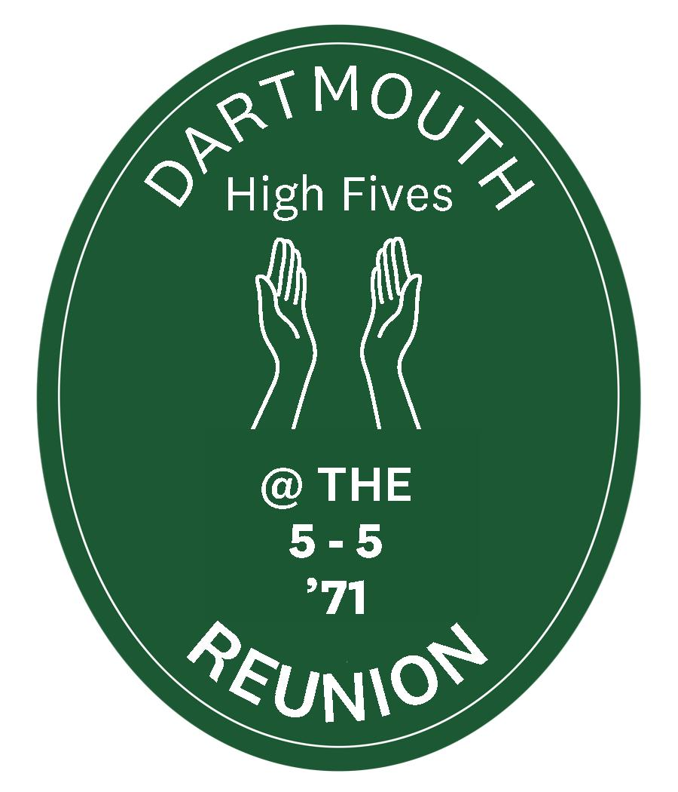
Memorials and Remembrances
May 2026

Classmate Date of Death
Russell ADAMS 8 January 2025
Mark Robert BARDO 13 March 2023
Gregory A BOYT 31 August 2021
Barbara L. BRITT 17 August 2023
Stephen Swift BROCKWAY 6 January 2026
Francis Xavier CANNING 29 September 2023
Matthew Brook CARROLL 18 May 2024
Charles Bristol DUNCAN 3 May 2021
Peter M ETZEL 15 December 2022
Michael Leo FAY 18 March 2024
Gordon Bennett FLINT 28 July 2023
Gary GASPAR 22 December 2024
Malcolm L JONES 17 July 2023
Peter Michael KALDHEIM 27 October 2023
Kevin KANE 6 February 2026
Robert Leo KELCOURSE 14 July 2024
William Petersen KENNEDY 18 June 2022
Gunnar Elias KLINTBERG 28 April 2023
Robert Yamins LIDER 18 August 2022
Harold Y. MCCULLOCH 23 October 2023
Colby Shannon MORGAN 24 May 2022
William Hammer MUNICH 1 March 2024
Kevin Robert MURPHY 11 October 2024
Charles Ralph "Jake" PAUL 20 August 2024
Randolph Howard PHERSON 11 January 2024
Willard RILEY 10 April 2021
Peter ROITMAN 2 October 2025
Vance Howard SMITH 4 May 2024
Robert Bruce TEPPER 17 September 2024
Scott Taylor WILEY 1 August 2025
Richard Willet WOOSTER 28 February 2026
Fred Charles YOUNG 3 November 2025

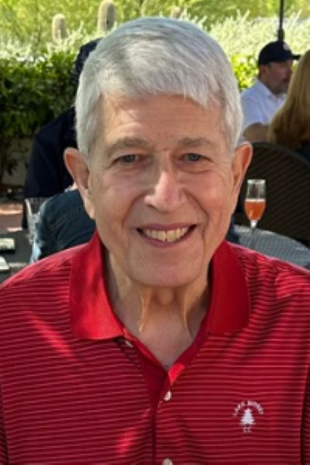
Russell Adams
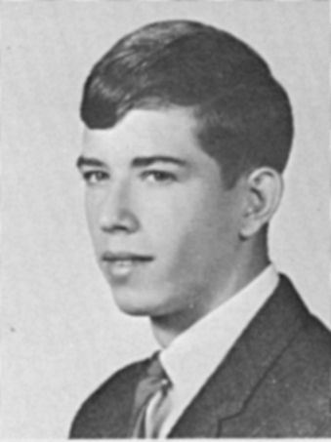
TEWKSBURY: Russell Leigh Adams, age 75, a resident of Tewksbury for over 40 years, passed away at Tufts Medical Center on Wednesday, January 8, 2025. He was the beloved husband of the late Mary Louise (Best) Adams.
Russell was born on April 15, 1949 in New Castle, Pennsylvania. He was the second son of the late Stanley Paul Adams and Velma L. (Shelar) Adams of New Wilmington, Pennsylvania. He was raised in New Wilmington and had a childhood playing in streams, woods and fields with other kids from the neighborhood. He and his brother were involved in the local 4-H as well as the Boy Scouts where he became an Eagle Scout. Always competitive, he gravitated to sports and played football, basketball, baseball, and track at Wilmington Area High School from where he graduated in 1967. He also
played the baritone horn in the band and sang in the chorus.
Russell followed his older brother Bill to Dartmouth College in Hanover, New Hampshire. He earned his BA in 1971 and followed with a year at the Thayer School of Engineering, where he earned his Bachelor of Engineering in 1972. He was a three-year starter at defensive halfback in football. He played on Ivy League title winning teams in 1969 and 1970. The 1970 team was one of the best in Dartmouth and Ivy League history. They went a perfect 9-0, won the Lambert Trophy signifying them as the best college football team in the East, and finished the season ranked #14 in both major polls. It
was the last time an Ivy League team was ranked in the final AP Poll. Russell was also a three-year letter winner in baseball. He played 1st base and center field for the 1970 team that won the Eastern Intercollegiate Baseball League championship and advanced to the College World Series. Not surprisingly, his time at Dartmouth played a central role in his life and he often regaled friends and family with tales from those years.
Following graduation, Russell pursued a career as a Civil Engineer, focusing on water and wastewater infrastructure. He worked on the design or program construction management of major projects for both the Metropolitan Water Reclamation District of Greater Chicago (MWRD) and the Massachusetts Water Resources Authority (MWRA), including the Skokie (IL) North Side Sewage Treatment Plant and the Deer Island (MA) Wastewater Treatment Plant. In 2006, he worked as a contractor with FEMA and commuted between Massachusetts and New Orleans to aid with the recovery following Hurricane Katrina. Throughout his career he was active in multiple professional societies and particularly so in
the New England Water Environment Association (NEWEA), for which he served as President in 1995.
Russell met the love of his life, Mary Louise Best on a blind date to watch a younger cousin play Little League baseball in 1971 in Mercer, PA. They were married on July 14, 1973 in Emlenton, PA with the reception at the nearby Foxburg Country Club. That year, they moved to the Chicago area and settled in Schaumburg, IL. They had their first son, Matthew, in 1978, and second son, Jonathan, in 1983. During this time, Russell attended night school at the UChicago Booth School of Business and earned an MBA in 1980.
In 1984, the family moved to Tewksbury, Massachusetts. Both Russell and Mary Lou became active members and proud supporters of the Tewksbury Congregational Church. He loved singing in the choir and served as a Deacon as well as the chair or member on the Finance, Building, and Stewardship committees. He was a devoted and nurturing father who took an active interest in his sons' education and athletic endeavors, often coaching their town league teams.
An apartment adjacent to a golf course in Hoffman Estates, IL led to a lifelong passion for the sport. He played as often as he could, especially in his later years. Russell always enjoyed conversation with anyone he met, a congeniality that grew out of his Western Pennsylvania roots. Russell loved his family, maintained lifelong connections with friends, and had an incredible ability to always look on the brighter side of life.
He is survived by two sons, Matthew R. Adams and his wife Sarah of Chicago, IL, and Jonathan R. Adams and his wife Sharon Bielik of Stoneham, MA; three grandchildren, Owen, Eliana, and Daniel; one brother, William P. Adams, M.D. and his wife Carol of Fountain Hills, AZ; and one sister-in-law, Nadine Karl of Franklin, PA. Russell was a beloved uncle to his niece and two nephews and is much beloved by several cousins.

Remembrances
Jonathan Ward Osgood - 1/17/2025
Russ was one of my favorites. We met early on freshman year in New Hamp Hall, and were Kappa Sig fraternity brothers. Obviously, a talented athlete and business professional, Russ was also an upbeat and kind human being. My sincere condolences to his family.
John Thomas Hanley Jr - 1/18/2025
I had the great fortune of sitting next to Russ at the homecoming football game against Harvard. We shared many stories from Thayer school and from his success playing football and baseball. I was as close to Russ as all but a couple of other classmates. He was always a gentleman and a pleasure to be around. We will miss him.
Robert B. Schnabel - 1/18/2025
It always was such a pleasure seeing Russ at class and football reunions; as people have mentioned he was such a positive, friendly (and accomplished) person. Will greatly miss him! Bobby Schnabel
Gregory Edward Fell - 1/18/2025
I did not know Russ very well at Dartmouth other than as a fan of his exploits on the football and baseball teams, both historic programs at the time and to this day. In recent years at reunions and games I loved speaking with him to hear stories of those teams which I remember so well. I don't know why, but I think of our great athletes in the class as somehow indestructible and will live on forever. Alas, that is not the way life is. Russ will be fondly remembered by all who knew him, great guy, great athlete, great person.
Roger Prince – 1/18/2025
Russ was down the hall in 109 New Hamp freshman year. Dan Clouse, John Shanahan and myself were in 103. Sophomore year Shanahan and I took over 109 as I recall. I don't remember who Russ was rooming with. I credit Russ with demolishing a stereotype of mine. My small high school didn't have football and I arrived at Dartmouth with the view that all football players were jocks and full of themselves. I immediately liked Russ and it wasn't until later that I learned he was a star athlete. I started giving all those jocks in New Hamp a second look. It became obvious that the football team was a representative sample of students at Dartmouth. Yes, they were better athletes than most of us, but their personalities, interests, and ambitions were as varied as the student body as a whole. I think I finally began to stop seeing people quite so one-dimensionally. So thank you Russ for opening my eyes.

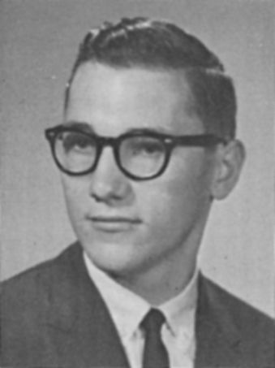
Mark Bardo
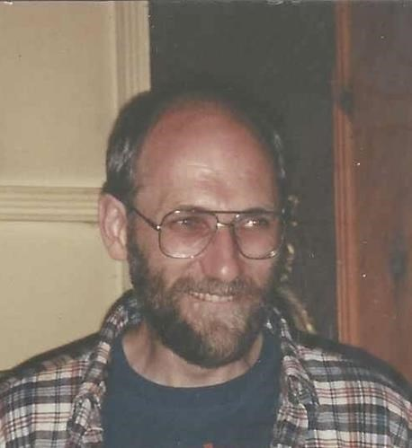
Concord, NH - Mark Robert Bardo, age 73, passed away peacefully at the VNA Hospice House in Concord, NH on March 13, 2023, after a valiant fight with pulmonary fibrosis. He was born the sixth of eight children in Danbury, Connecticut to Charles and Lillian (Ruopp) Bardo and enjoyed his formative years on the family farm there.
After graduating from Dartmouth College, he went on to Dartmouth Medical School and graduated from the two- year program in 1972. Mark transferred to the University of Washington to complete his medical degree. During his tenure there, he pursued his interest in medicine by joining the Peace Corps and served in South Korea as a community health volunteer. After graduating in 1978, Mark began his family practice residency through the University of Colorado in Pueblo. He practiced medicine for almost 40 years in Pueblo, CO, Libby, MT, Concord, NH and Barrington, NH. He said the favorite part of his workday was when he would walk into an exam room, and say, "How can I help you today?" He will be remembered as a humble, caring, kind and loving man.

Mark loved his family and was so proud of them! A modern-day Renaissance man, he loved to take on projects and volunteered his time in many community activities. He loved anything made of wood, anything made of stone, and anything with the potential of being repurposed--just ask anyone who knew him. A lifelong learner, Mark had an atlas and dictionary in nearly every room of the house. He had a great love for the outdoors, whether skiing in deep powder, fishing along a quiet river, or finding God's beauty in majestic forests.

He is survived by his wife of 43 years, Elisebeth (Betsy) Eble Bardo, his three children, son Nicholas, and wife Joanelle and grandchildren Maya and Koa of Grand Junction, Colorado; son Samuel of Honolulu, Hawaii; and daughter Johanna of Grand Junction, Colorado. He is also survived by his seven siblings: Karen, Richard, Theodore, Alan, Brian, Bruce and Elaine and numerous nieces and nephews.
Remembrances
Wayne Petrie Hobin - 11/29/2023
I was a suite-mate of Mark's soph year in Bissell in the Choates. We were both pre-meds. I found Mark to be very studious but also had a great sense of dry humor. The two pictures above demonstrate both aspects of his persona. We had classes in common along the way but I was buried in Kiewit or Bradley (Math and Comp Sci) or was working in the Reserve Room most of the time so we met only occasionally. I still remember him when I think about the fun times we had in Bissell. "The North Hills will Remember His Name".

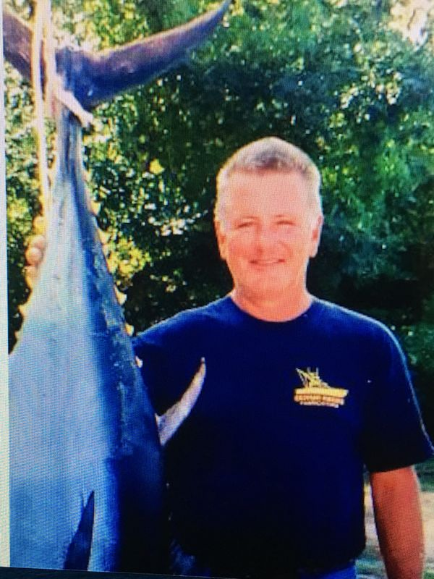
Greg Boyt
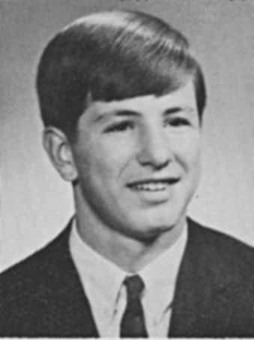
Buxton - Gregory A. Boyt, 72, of River Road passed away Tuesday August 31, 2021 at his residence in Buxton, ME. He was born in Nyack, NY April 22, 1949 the son of Alexander and Helen Biltz Boyt.
Greg grew up in Cohasset, MA and graduated from Dartmouth College in 1971 with an A.B. degree in Earth Sciences/Geology. He worked for several years in sales before attending and graduating from Suffolk University Law School. Greg owned and operated for several years Valve Services and Maine-ly Towers doing paper mill maintenance/shut-downs and fabrication for tuna towers. He then worked as a lobsterman and fisherman out of Pine Point for over 10 years.
For the last 15 years, he has worked for the Small Business Association doing Disaster Relief.
Greg enjoyed fishing, gardening, the company of Cindy’s many animals and his desserts! And he especially enjoyed his time with all of his friends and the neighborhood kids – they were family to him.
Survivors include his companion of 25 years Cindy Cook of Buxton, his daughter Kristin Boyt of Rye, NH, his sister Susan Boyt of Chicago, nephew and godchild Brian Boyt of Pine Point and sister-in-law Cindy Boyt of Old Orchard Beach.
Greg was predeceased by his parents, and three brothers Alexander, Stewart and Andrew Boyt.

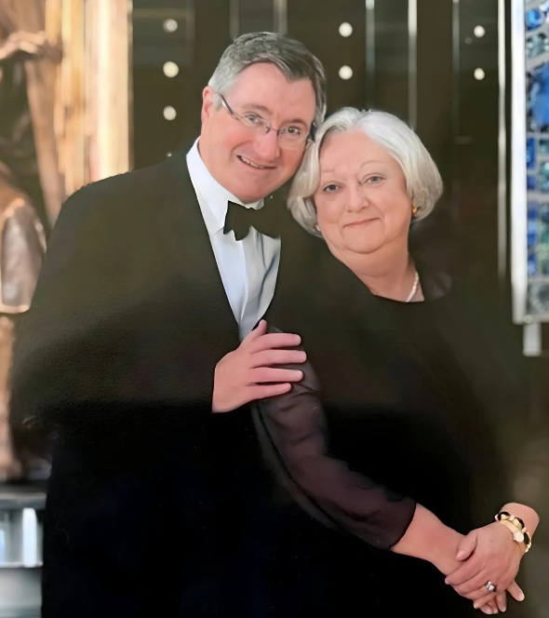
Barbara L. Britt
Barbara L. Britt died in Manhattan at her home on August 17, 2023, at the age of 79. Born on January 16, 1944, in New York City to James G. Little and Margaret (Kling) Little, Barbara considered herself a New Yorker, but resided for many years in Westport, CT, and owned a home in Kailua-Kona, Hawaii. She graduated from Douglass College in New Brunswick, New Jersey in 1965 and married Glenn Britt [Dartmouth class of 1971] on October 25, 1975; Glenn died in New York in 2014. Barbara is survived by her brother, Kevin Little, his wife, Lynn Hobbie, and daughter Margaret Grace Little of Madison, WI. Barbara's brother was with her when she died.
Barbara's family is grateful for Barbara's friends who graced and enriched Barbara's life. We thank the physicians who listened to Barbara and supported her choices. Barbara was blessed to have a team of nurses and aides who provided skilled and kind care in Barbara's final weeks.
Note: In 2024, Dartmouth College received the bequest of over $150 million from the estate of Barbara and Glenn Britt, the largest scholarship bequest in its 255-year history. Barbara’s death in August 2023 activated the bequest, which will fund a new Britt Scholarship at the college and a Britt Scholars program at Tuck.
Remembrances
Kathy Cragan – Aug 21 2023
May Barbara now rest in peace and reunite with her husband, Glenn. I will remember her quiet ways. It was always a pleasure to work with her as we did various interior projects together. She will be missed. Godspeed to the family.
Sally Lord Stillwell – Aug 21, 2023
Barbara served as photography editor on our yearbook, Quair, at Douglass College. I am grateful for her contributions to Douglass and offer my sympathy to her family

Stephen Brockway
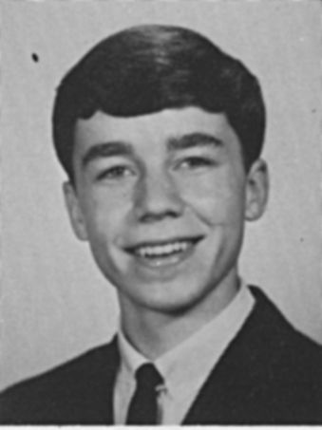
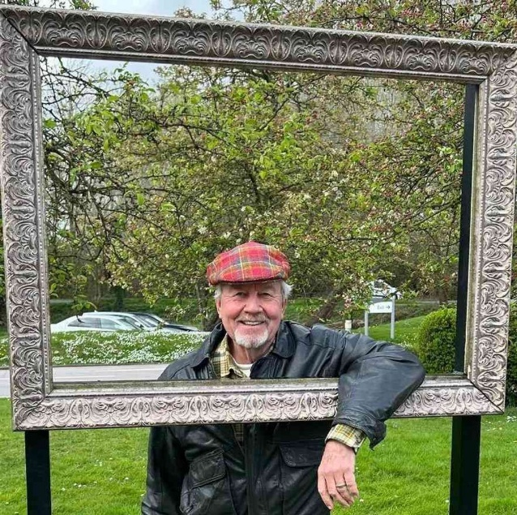
Stephen ("Brock") Brockway, MD, was an adventurer and an explorer, a cowboy and a mountain man, a reader and a poet, a physician and therapist and healer. He was a father and new grandfather, and he considered parenthood his highest and greatest calling.
Brock liked nothing more than to hike into the desert mountains with Yorkshire tea and his dogs, and he did that most dawn mornings in retirement. Prior to that, he worked for 44 years as a psychiatrist: running a combat stress unit, pioneering group therapy for veterans who suffered from the newly-recognized "Post-Traumatic Stress Disorder" (PTSD); then working as chief psychiatrist and medical director at the Meadows, in Wickenburg, AZ, treating people with sex and drug addictions, along with other trauma-based mental health issues.
Brock earned his medical degree from the Medical College of Wisconsin at Marquette and his undergraduate degree from Dartmouth College, where he captained the rifle team, served as a search and rescue mountaineer, and tutored Native American students who came to Dartmouth from reservations.
After a near-death experience in college, Brock pursued a lifelong devotion to faith: seeking to understand and grow deeper connection with God.
He also was a political and news junkie. A student of both history and psychology, he recognized the fascism growing within the U.S. nationalist movement far earlier than most, and he never feared to speak his mind and share the truth he saw.
In fact, it didn't seem like Brock was afraid of anything. And when the cancer diagnosis came, he faced that too with courage. Late in life he met and married his wife, Hillary, and with her he experienced, despite his cancer, possibly the happiest period of his life.
Brock will be missed by his sons, Ross (a lawyer in Atlanta) and Ben (a professional hockey player in Michigan); his wife, Hillary (now a single parent to their four dogs); his granddaughter, Leona; his many former patients and colleagues; and friends around the country whom he treasured.

Remembrances
David Aylward-
I wrote this to Brock 6 weeks before he died:
I have come to think of close friends like you as recurring comets circling my planet in our shared galaxy, forces of energy and brightness that are not in my existence on a daily basis, but over time have returned repeatedly to my life to add joy, wisdom, or some other unexpected gift. It’s a comfort to know that you’re there, even when in a particular orbit you are not yet close to me.
I didn’t think much about this circle of friend relationships until the last 15 years when I began investing more time in the people and relationships of those kinds from years ago.
Our little Zoom group from Dartmouth/South Fayerweather was the first organized version of that. Outside of those communications, your wisdom about PTSD has stuck with me long, long after you imparted your thinking years ago. I loved your stories of counseling the Native Americans in college which I only heard 50 years later when we were putting the 50th reunion book together.
You think about and look at the world in a different way than I do. I deeply admire and appreciate how you devoted your career to helping deeply traumatized people in ways I could only understand at a very high level.
I admire the courage you have shown in the face of your cancer. It is an uplifting lesson to all of us as we each confront our own mortality and the illnesses that come with age (in my case, most recently, Parkinson’s).
So, thank you for being such a good comet for me, and a fine friend. Email, text or call anytime.
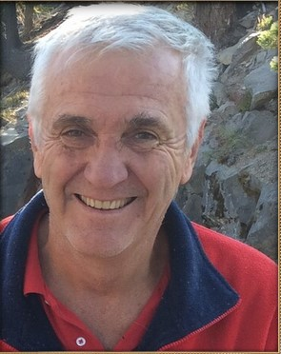
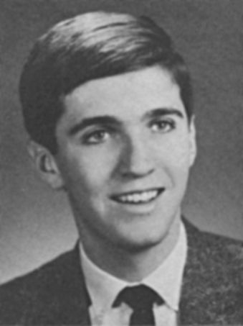
Frank Canning
Francis X. Canning died on September 29, 2023 at the age of 73 in Lancaster, California after fighting Hodgkin’s Lymphoma. Francis grew up in Stony Brook, New York, where he discovered his love of the water, beginning a lifetime of sailing, kayaking, and boating. He received his Bachelor's degree at Dartmouth College in New Hampshire before completing his Doctorate in Physics at the University of Massachusetts, Amherst.
He was a brilliant mind and led a passionate career dedicated to many years of civil service. He began his career at the Naval Air Weapons Station China Lake in Ridgecrest in 1982 and after decades of life and work in Southern California and West Virginia, including raising a daughter, returned to China Lake for the remainder of his devoted career. Francis then felt a pull back to the hills of Appalachia and retired to his lakeside retreat in Morgantown, West Virginia.
Francis was a loving father, brother, friend, and soon to be grandfather. He displayed a passion for being active outdoors throughout his life, from scuba diving to hiking to boating, and instilled a love of the outdoors in others.
He is survived by his daughter, Rachel Canning of Mammoth Lakes, California, brother, Robert T. Canning of Inyokern, California, sister, Margaret O’Reilly of Venice, Florida, and sister, Kathleen Lund, of San Diego, California.

Matthew Carroll
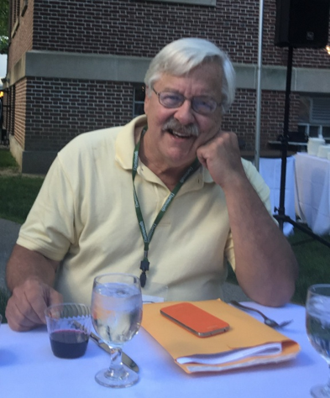
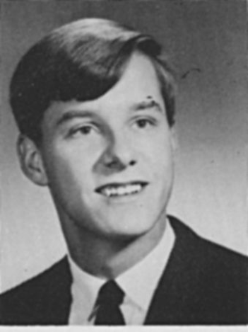
Matthew's sister, Susan, sent the following notice to Dartmouth College and to our class secretary. I have edited it a bit for clarity and accuracy.

Dear Dartmouth,
I'm sad to share the news of my brother's death, Matthew Carroll, class of 1971. He had a large brain and a big heart; the former he donated to the Harvard Brain bank.
Matthew B. Carroll died on May 18, 2024, at his home in Saratoga Springs, New York.
His two children, Alison Frederickson and Doug Carroll, and two of his four sisters, Susan and Sara survive him. He received an MBA from Harvard University (1977), his BA from Dartmouth College (1971), and was a graduate of Westfield High School, NJ (1967). Matt worked for pharmaceutical and retail corporations before starting his own businesses, most notably Innovative Cleaning Concepts (ICCI), a manufacturer of cleaning products, which he ran for more than twenty years. He enjoyed playing chess, bridge and invented games, including "Riskopoly" while at Dartmouth.
Matt, a psychology major, often returned to Dartmouth through fond memories. He attended his 50th reunion and appreciated the massive Reunion book. Unfortunately, he didn't finish reading it before succumbing to the forces of time and physical decline. Death happens to the best of us.
Regards,
Susan Carroll (Executor)
Your webmaster has gleaned the following additional information from public records:
Matthew Brook Carroll was born Jan 2, 1949 to Dr. L. Douglas Carroll and his wife of Scotch Plains, New Jersey. His father had been executive director of the Tri-state Planning Commission in New York City and his mother was president of Nevatoss, a news clipping service. On 19 Dec 1981 Matthew married Brenda Sue Richards in Fanwood, Union, NJ. At the time he was president of Continental American Industries Corp, an Atlantic City based development group. She was a Vanderbilt Univ grad and a systems analyst with the NYC based consulting firm, American Management Systems. They moved to Houston in the 1980s where daughter Alison and son Douglas were born. They divorced 2 June 1998 in Harris county Texas. Matthew remained in Houston until at least 1998, but had moved to Albany NY by 2016 and then Saratoga Springs, New York by 2019, where he passed away.
Charlie Duncan
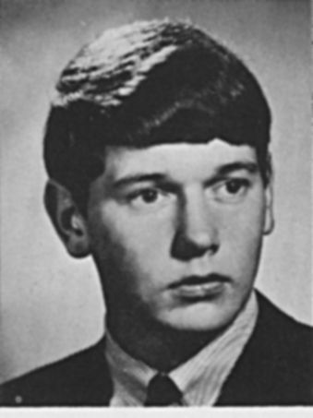
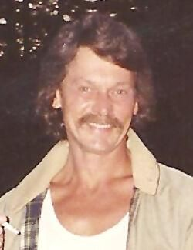
Charles B. Duncan ’71 of Claremont, New Hampshire, passed away at home on May 3. Charlie was the first of five children born to Richard C. and Theofilia (Wiltowski) Duncan. Raised in Newport, New Hampshire, he graduated from Newport High School in 1967 and went on to earn an A.B. in religion in 1986 from Dartmouth, where he was a member of Gamma Delta Chi. He later earned a certificate from New England School of Alcohol Studies. Charlie was an easygoing guy who was happy to help his friends and others. He had a great sense of humor and loved sharing stories. Among many jobs, his favorite by far was building dry stone walls. Self-employed as a dry mason, his artistry is displayed at many public and private venues, including the garden walls of the Tracy Memorial Library in New London, New Hampshire. Charlie was predeceased by his parents and his loving companion, Marlys. He is survived by sister Janis and her husband, Edmund; sister Barbara and her husband, Sam; brother Thomas; brother William and his wife, Jo-Ann; stepsons Troy and Tommy; daughter Fran and her husband, Jason; grandchildren Justin and Samantha; niece Rebecca; and nephews Matthew and Riley.

Pete Etzel
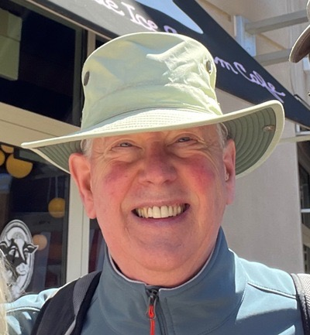
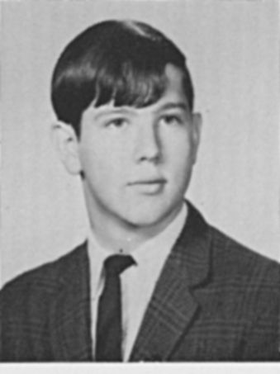
Peter M. Etzel of Norwell, beloved husband, father, and grandad, peacefully passed away on December 15, 2022 at Brigham and Women’s Hospital with his wife and son at his side.
Peter fought a courageous 10-month battle against the ravages of glioblastoma, rallying again and again, with the help of the Norwel VNA, to be able to spend more time with his family, creating many cherished memories for them.
Peter reluctantly left behind his wife Peggy "Peg of his heart," his loving son Michael and daughter "in-law" Caitlin (Monahan), and the lights of his life, granddaughters Orla and Maeve.
Outdoor pursuits were Peter’s passion, starting with family camping trips and many summers spent at Boy Scout camp as a child growing up in Greenwich, CT. Soccer, skiing, and hiking were added to the mix during his years at the Berkshire School in Sheffield, MA as a member of the class of 1967. His love of the outdoors continued at Dartmouth College, where he graduated with an AB in Psychology in 1971, and the Amos Tuck School at Dartmouth, where he received his MBA in 1972.
Peter instilled his ability to find joy and solace in nature to Michael, strapping him in a backpack as a baby—the beginning of hiking, and later skiing, trips together. Excursions to Wompatuck State Park became a fixture after Peter’s move to Norwell with his family in 1989.
Travel also became an important part of Peter's life, beginning with a honeymoon trip to Tahiti after his marriage to Peggy on New Year's Eve in 1977. They planned to spend their upcoming 45th anniversary at a ball in Vienna, but that was not to be. Over the years the islands of Hawaii, the coast of Maine, and California's wine country became favorite destinations. Peter spent 35 years in the pharmaceutical industry, holding a variety of positions at Pfizer, Squibb, Organon, Lederle, Serono, and Polymedica where he managed their pharmaceutical division. He shared his in-depth knowledge and insights his family, friends, and often his doctors.
After his retirement from his position sourcing medical contracts for the Commonwealth of Massachusetts in 2018, Peter could often be seen outside his Norwell home meticulously hand weeding the lawn, chatting with neighbors as they passed. He enjoyed puttering in his workshop and working out in his home gym, as well as walks in the woods or on the beach.
Reading was always one of Peter’s favorite pastimes. He became a frequent visitor to the Norwell Public Library, devouring the works of many science fiction authors, as well as the latest mysteries from his favorite writers.

As much time as possible during his retirement was spent reading to and playing outside with his cherished granddaughter Orla. Patiently reading to her for hours on end created a special bond between them, deepened during the year of COVID when the extended family quarantined together. Baby granddaughter Maeve was his birthday twin, entering the world on what was to be Peter’s final birthday this past January.
Peter was an active member of the Norwell community where be coached Michael’s Norwell Recreation soccer team for eight years. He also served on the Norwell Board of Assessors and was a frequent Norwell Town Meeting participant. As a Grand Mason at Phoenix Lodge in Hanover, MA for 18 years, Peter often used his skills, honed as sous chef to Peggy, to help prepare the food for the Lodge’s monthly breakfasts.

Remembrances
John B. Wason - 1/14/2023
Pete was in our group at Bourges, France in the fall of 1968, the inaugural term of the Dartmouth Foreign Language Program. He's the guy I went to Paris with on that fateful weekend I wrote about earlier. We jokingly called him "Sex" Etzel not because of Place Pigalle, but because he seemed to be getting so much mail from various girlfriends back home. I don't think he liked the nickname much, but he good-naturedly tolerated it.

Mike Fay
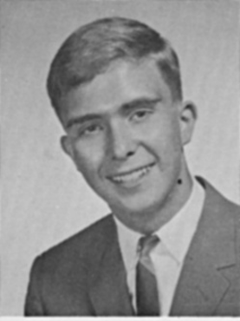
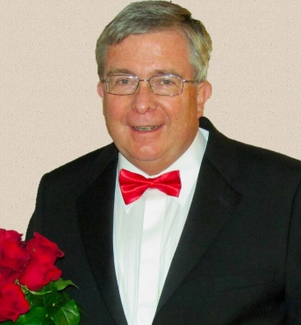
Michael Leo Fay, age 74, died unexpectedly on March 18, 2024 after falling ill doing what he loved: taking his daily neighborhood walk, while stopping to greet every dog and neighbor with the warmth of someone at last reunited with a beloved family member. Michael developed national renown as a trusts and estates attorney over the course of his nearly 50-year career, a career he enjoyed to the last day of his life. Above all, Michael was a loving husband to Carol Buckley; a brother to Kevin Fay; a father to Matthew, Kathryn, and Christopher Fay; a stepfather to Kate and Tim Naber; a grandfather to River and Eleanor; and a good friend to many. His counsel was trusted, his jokes were intended to be funny, and his singing voice was actually quite good. He is missed terribly.
Michael was born on October 3, 1949 in Springfield, MA, where he and Kevin were raised by Marie and Joseph Fay. After graduating from Springfield’s Classical High School in 1967, Michael graduated Phi Beta Kappa from Dartmouth College in 1971, Oxford University’s Keble College in 1972, and Harvard Law School in 1975. He maintained particularly close ties to Dartmouth College for the rest of his life. His pride for his alma mater was rivaled only by his celebration of loved ones’ accomplishments.
As an attorney, Michael was valued by clients for his expertise and good judgment, and he was sought out by journalists from the Wall Street Journal, Forbes, Time, NPR and other outlets for his ability to explain complex topics with concision and clarity. To his mentees, he was known for his commitment to their legal development, including delivering what he jokingly called his “sermonettes:” mini-lessons on “what you don’t learn in law school.” His professional accolades are too numerous to list, but by way of example he was recognized as one of Worth magazine’s “Top 100 Attorneys,” and was listed for the last 30 years as one of The Best Lawyers in America for Trusts & Estates.
When his children were younger, Michael would take them to the beach on sunny days and go “puddle-hunting” (the goal of which was to make the largest splash) on rainy days. He instilled his sense of curiosity and love of learning in his children from an early age, which continue to shape their lives as adults. With the arrival of two grandchildren in 2023, he reveled in and excelled at his new role as Grandpa Fay. Michael was an avid story teller and aspiring comic. Though he passed too soon, his family will continue to tell his stories and jokes.
Remembrances
Robert Joseph Cordy - 3/23/2024
I was heartbroken to hear of Michael’s passing. Our paths crossed many times at Dartmouth, Harvard Law School and in our separate law practices in Boston. He was one of the nicest and most generous persons I have ever known. And such a lover of and contributor to Dartmouth College. He will be so missed by all of us.
Dolly Fleet Corlin 3/30/24
It was very shocking and sad to learn about Mike Fay's passing. He was one of the most kind, thoughtful and generous people possible. My memories of him start with first meeting outside Bissel Hall in the fall of 1969, running into him in Cambridge after graduation, looking forward to seeing him at every reunion and homecoming that I attended. My last memory is Mike's entertaining with jokes during the Friday night dinner at Homecoming. Mike worked at Hale and Dorr with one of my family members. Both of their sons coincidentally met in another country. We kept up with each other through updates during family events. Among ways that Mike looked out for others include his sharing his expertise in Estate planning, along with Charlie Collier, at the 40th reunion in 2011 and during a zoom seminar during COVID. It will be tough to attend the next event without seeing both Mike and Bob Lider.
Gordon Flint
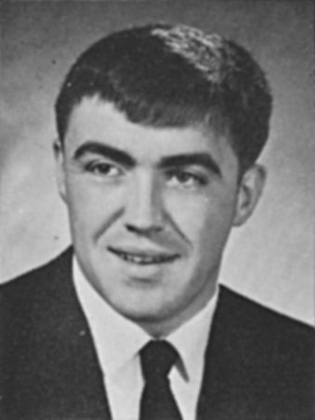
Newport, NH-Gordon B. Flint, Jr., 74, of DeWalt Avenue, died Friday, July 28, 2023. He was born in Claremont, NH on April 2, 1949 the son of the late Gordon B. and Dorothy (Minor) Flint, Sr. He graduated as Valedictorian from Newport High School in 1967 and attended the St. Paul’s Advanced Study Program between his junior and senior year. He considered that program to be the best preparation for Dartmouth where he graduated in 1971 magna cum laude. Very active at Dartmouth, he was a member of the Glee Club, Band and Kappa Kappa Kappa Fraternity. Gordon worked as an intern with the NH Office of State Planning. At age 21, he was one of Newport’s representatives to the General Court during the 1971-1972 session, being the youngest member. He received the degree of doctor of jurisprudence from the University of VA School of Law in 1974.
Gordon returned to Newport in 1974 and had been an associate with John C. Fairbanks for several years until becoming self employed in the 80’s. He retired in 2007.
Athletic and musical, Gordon played football, track, baseball and basketball. He sang with the Newport Area Choir, played in the original Opera House Band, played with the East Bay Jazz Band and the Mad Bavarian Brass Band. He played the trumpet for weddings and area churches. Gordon had served on the Newport Opera House Board of Directors and performed in many shows including Sound of Music, Music Man, Annie Get Your Gun, Pajama Game, Carousel, and A Funny Thing Happened on the Way to the Forum. One of the things that was most meaningful was that he played Taps the first year at the NH Veterans Cemetery during the 100 Nights of Remembrance.
Gordon was a member of the South Congregational Church and a former member of the choir, had served on the school board, was a judge in the District Court in Newport and had been a member of the Lions Club and the Rotary.
He is survived by his wife of 42 years, Sandra (Bodge) Flint of Newport, NH; in-laws, nieces, a grandnephew, a grandniece and cousins.

Remembrances
Roger Prince-
Gordon and I were in the Marching band together. He was a trumpeter like Malcolm Jones. I believe he was one of a quintet or so of brass players who played baroque brass pieces and Christmas carols from the walkway below the Baker Tower clock at Christmas time. I loved hearing that brass music floating across the green. Jim Low, who was a tuba player in the band, may also have been part of that group.

Gary Gaspar
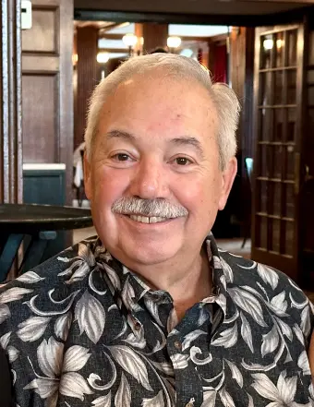
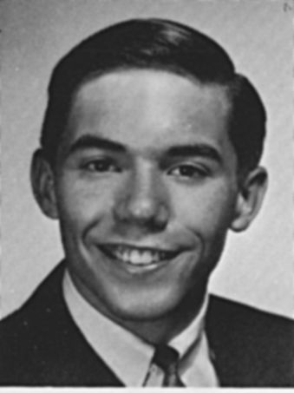
Gary J. Gaspar, age 75, a cherished resident of Naperville, IL since 1986, passed away on Sunday, December 22, 2024, at Endeavor Health Edward Hospital in Naperville. Born on July 20, 1949, in Springfield, MA, Gary lived a life filled with love, laughter, and connection.
Gary was the beloved husband of Joanne Gaspar (née Johnson), with whom he shared over 50 years of marriage. Together, they built a lifetime of memories, including a special family trip to Skytop this past summer, where they celebrated their golden anniversary at the same place they honeymooned decades ago.
A devoted father to Kirstin (Max) Chernawsky of Naperville, Gary’s joy was his only child, whose accomplishments and happiness brought him immeasurable pride. He had a special fondness for his only son-in-law, Max, who was undoubtedly his favorite. Gary’s love extended to his "grand" pets, Logan the cat and Oliver the dog, who brought him endless joy.
He was the dear brother of Ken (Pam) Gaspar of Southampton, MA, and a loving uncle to Jonathan (Trish) Gaspar and Jameson (Angie) Gaspar. He was also the brother-in-law of Suzanne (Bill) Harris of Naperville and a fond cousin, great-uncle, and friend to many. Gary was preceded in death by his parents, the late Orlando “Lanny” and Dorothy “Suzie” (née Belliveau) Gaspar, who instilled in him the deep values of kindness and family.
Gary’s family and friends will fondly remember him for his wit, warmth, and many passions. He loved playing games with Joanne, Kirstin, and Max, often sharing elaborate "dad jokes" that left everyone smiling. He found joy in curating his extensive music collection, spending quiet moments on the porch, and taking his annual golf trip to Myrtle Beach with his brother, family, and dear friends. He also cherished time with his ROMEO (Retired Old Men Eating Out) Thursday breakfast group. An avid sports fan of all things Boston, Gary reveled in the success of his beloved teams, often sharing his enthusiasm with family and friends.
A graduate of Classical High School (Class of 1967) in Springfield, MA, and Dartmouth College in Hanover, NH, where he earned a degree in Psychology, Gary was admired for his intellect and work ethic. He began his career as a program analyst. Gary spent 27 years with North American Company for Life and Health Insurance (later Sammons Financial Group) in Chicago and rose to the position of Chief Information Officer before retiring in 2012.
Gary’s deep love and unwavering support for his family were at the heart of everything he did. Whether sharing a story, planning a trip, or simply being present, he made every moment with his loved ones meaningful.
Gary will be dearly missed by all who knew him, but his memory will live on in the laughter he inspired, the music he shared, and the love he gave so freely.
Remembrances
John Orange-
Spar was more than a fraternity brother. We shared the highs and lows of Dartmouth Soccer all four years and usually roomed together on the away games. Many special memories were created with the last Saturday night of each season in New York City, compliments of Dartmouth, tops on the list.
Wayne Hobin-
Gary was a great guy. I knew him because I was in the Choates behind Kappa Sig and our paths crossed many times. Always a smile and he was always upbeat with kind words. I had a long conversation with him several years ago when I was pimping for the DCF as class head agent. He was still the bright star in the sky.
John Osgood-
Sadly, another fraternity brother gone. I'll always remember Gary for his friendliness and always upbeat attitude.
Dan Clouse-
Gary was an alum of Springifeld (MA) Classical H.S. Other well-known alums were Theodor Geisel, Taj Mahal, William Manchester, and Timothy Leary.

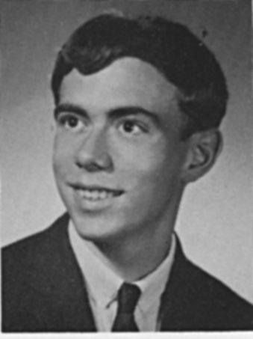
Malcolm Jones
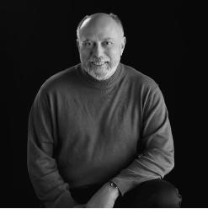
Malcolm L. Jones, Jr. passed away on July 17, 2023, in Truckee, CA. He was born on March 31, 1949, in Oak Park, IL. Malcolm graduated from West Aurora High School in Aurora, IL, received his undergraduate degree from Dartmouth College in Hanover, NH, and his MBA from the Kellogg School of Management at Northwestern University in Evanston, IL. Malcolm's time at Dartmouth laid the groundwork for a future defined by intellectual curiosity, resilience, and a commitment the arts. He maintained a lifelong commitment to Dartmouth, which started immediately after graduation when he worked as the Director of Development in Chicago. Malcolm thereafter embarked upon a career in investment banking that would make him a recognized figure in the world of public finance both in New York and in California.Beyond his notable career, Malcolm will be most remembered for his love of family, and his unwavering passion for music, art, travel, adventure, and all things Dartmouth. These passions took him throughout the United State and the world. His appreciation for the arts and his adventurous spirit enriched his experiences and endeared him to those who had the privilege of knowing him.A big joy in Malcolm's life was to give back to the community. He served on dozens of nonprofit boards across the country that promoted education, music, and the arts. He particularly loved the symphony and was a consistent patron to the Chicago, Los Angeles, and San Francisco Symphonies. He served on the Development Committee of the San Francisco Symphony for nearly 40 years. Malcolm was preceded in death by his parents Malcolm and Lydia Jones, his sister Sara (Sally) Overstreet, brothers-in-law Tom Overstreet and Leon Nelson, and his fiancé Sandi Blodgett. He is survived by his sisters Donna Nelson, Susan Harms, and Linda Bloom, their spouses Gary Harms and Bob Bloom, his former wife Karen Roche, as well as thirteen nieces and nephews. Memorial services to celebrate his life and legacy will be held in Sausalito, CA at Christ Episcopal Church on September 9th at 2:00 p.m. and at Dartmouth College on October 21st. A graveside service was previously held on August 25th in Aurora, IL. In lieu of flowers, the family requests that donations be made to a charity of your choice that promotes music or art as a reflection of Malcolm's passion in those areas. Notes of condolences can be emailed to the family at lindabloom50@gmail.com. While we mourn the physical loss of Malcolm, we find comfort in knowing that his influence and impact will continue to resonate through the lives he touched. May we honor his memory by embracing knowledge, pursuing our passions, and cherishing the moments that make life truly meaningful.

Remembrances
Bobby Schnabel-
I only really got to know Malcolm during the last few years of his life, when I joined the group of head class agents which he was such an important part of. It was so great to get to experience Malcolm's legendary enthusiasm and dedication to Dartmouth. In the face of what he knew was a terminal condition, he had the most incredible attitude one can imagine and lived life to the fullest. We all miss him!
Willis Newton-
Malcolm was probably my closest classmate for many years as an adult in the Bay Area. Not so much because of me, but because he was so outgoing and full of life. He was incredibly organized and extremely active. When he came into San Francisco, he always wanted to combine a meeting or museum visit with a lunch or Symphony performance. And he created many mini reunions for classmates across the country and was the inspiration for a Symphony on the Danube cruise that was very well attended! We traveled together on several occasions and he was engaging with fellow travelers. In his last months, I provided support in any way that I could and I helped his sister and family with his affairs after he passed. In return I became the beneficiary of a collection of his Dartmouth memorabilia. I see something almost every day that makes me think of him.
His father went to Dartmouth and Malcolm had his senior cane. We talked about how disappointed we were that we didn't get to walk with the Class of 2021 at our 50th Reunion. I think this motivated me to see if we could open that door this year and now we can join the Class of 1976 on June 14, 2026 at our 55th!
David Aylward-
I did not know Malcolm in college. I do not know him until 2019 when he decided we were going to be friends. Coming to town for the memorial of the Dartmouth College Case, he emailed a lunch invitation as if we were all friends. I accepted, and after a two hour lunch at the Old Ebbitt Grill, we had become fast friends. We traded cancer stories. He told me about the quiescent cancer that would finally kill him years later.
Thereafter, I found myself connecting with him repeatedly because we were close friends. And I watched him create mini-reunion after mini-reunion. Later I organized virtual Zoom meetings of the “Malcolm Fan Club” to keep his spirits up, went to visit him in San Francisco when we all thought he was going to die, spoke about him as we scattered his ashes in the Bema, and finally, with Dave Brooks, scattered his ashes into the Rhine River on a trip he was supposed to join.
As I said at the Bema, he thought he had fallen short because he hadn’t become a big deal investment banker. But he had wildly succeeded at the thing he decided to do: building relationships, connecting people, bringing happiness.
He was really good at that.
Roger Prince-
Malcolm was incredible at keeping us all connected. There are some people who just form bonds and keep them going. As others said, it could be just a quick text out of the blue or a short phone call to say he was going to be near me next week and could he stop by to say hello. Although we knew each other as undergrads, we didn’t travel in the same circles other than the band. But him getting back in touch with me when I ended up in the Bay Area is really the reason I got reengaged with the class. I am forever grateful to Malcolm for his ‘superspreader’ friendship role. His interest and caring in everyone was genuine and made all of us feel special.

Peter Kaldheim
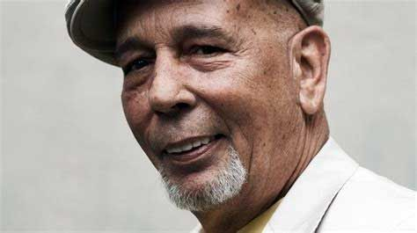
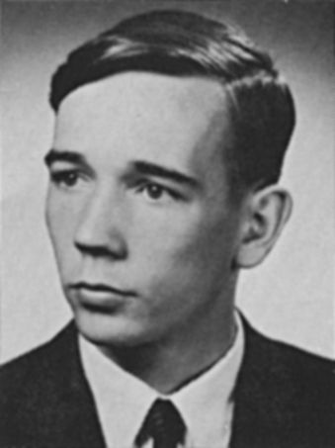
Peter Kaldheim died suddenly in Barcelona on Friday, October 27th, while delivering a monologue at the Kosmopolis Literary Festival. He was there to promote his acclaimed 2019 memoir IDIOT WIND, which had found an enthusiastic audience in Spain. The book, written in the spirit of Peter's literary hero Jack Kerouac, recounted a cross-country hitchhiking trip he made in the winter of 1987 when a series of bad choices made it necessary for him to leave New York City during one of the worst snow storms on record. The book was published in the United States, the UK, France, Spain and other countries. Peter was a graduate of Sachem High School in Ronkonkama, Long Island. After majoring in English at Dartmouth he worked as a copy editor in the college textbook department of Harcourt Brace Jovanovich, eventually becoming head copy editor, After that he worked for a time as an acquiring textbook editor for Van Nostrand Reinhold, until his publishing career was derailed by problems with addiction.
His cross-country trip landed him in Portland, Oregon, and then he found work as a cook at Yellowstone National Park. This began his new career in food services, which took him to Las Vegas and then to a position of authority for more than a decade at the University of Montana, Bozeman.
After retiring, he moved back to his hometown of Lindenhurst, Long Island, to care for his two ailing brothers, who died within a week of each other. He was a passionate fisherman and countless fluke found themselves hooked at the end of his rod in the waters off Montauk. About a year ago, he left Long Island to become a resident of Santa Fe, New Mexico. He is survived by cousins on Long Island. Everyone who was lucky enough to have known Peter knew him to be a warm, generous and witty man who made friends effortlessly wherever he went. He was a greatly talented writer and his early literary promise, while delayed for some decades, was triumphantly fulfilled in 2019 by the achievement of IDIOT WIND, a book Jack Kerouac would have surely approved of."
As Gerry noted, Peter had a great following in Spain, particularly Barcelona. His memoir of cocaine addiction, bumming across America, and living in homeless camps touched a nerve among his young Spanish readers. Perhaps it was the book's redemption story of Pete having finally overcome his demons. Perhaps it was the romanticism of the open road, oddball people, and enormous natural landscape of America that inspired them. For whatever reason, our classmate became a cult figure among the Catalan literary crowd. The most important newspaper in Barcelona, La Vanguardia, published a prominent article announcing his death, and the social media outpouring of shock and grief among the literary set was voluminous. As the novelist Juan Trejo wrote in La Vanguardia, Pete "leaves deeply dismayed the large group of friends that he had established in Barcelona and who had baptized him affectionately as the last beatnik."
Some of you will remember Pete the Hat (for the newsboy hat he always wore) on campus, or in English classes, where he wrote so brilliantly about literature. Others will smile at the memory of his participation in Phoenix shenanigans like the 1969 Fort Ticonderoga Raid or as one of the ponies pulling the winning chariot during Green Key Weekend '71. Some may recall listening in an altered mental state with Pete to "Theme for an Imaginary Western" by his fellow Long Islander Leslie West and the band, Mountain.
He was recognized with Citations by faculty for his precocious writing as a student, and some predicted that he'd have a novel published by his 25th birthday. That promise was catastrophically unfulfilled, and in the 25 years Pete wasted as a junkie and a bum, he squandered more talent than most of us could waste in several lifetimes.
Kaldheim was a late-life friend for me. After reading Idiot Wind in 2019, I wrote a note of appreciation, and with his typically kind and generous response, we began an email correspondence. It was pure joy to read the brilliant prose and tone-perfect humor of his replies. Pete's literary taste was exquisite and his reading voracious. I've never known anyone with anything approaching his enthusiasm and love for contemporary fiction, —especially the hard books.
Gerry Howard has called him the most gifted reader of our generation. Without him, one imagines young writers of unusual novels struggling now to find a Peter Kaldheim who gets it.
The Romans had sui generis. We have "one of a kind."
Both apply to our now departed but unforgettable classmate Peter Kaldheim.
by Dan Clouse

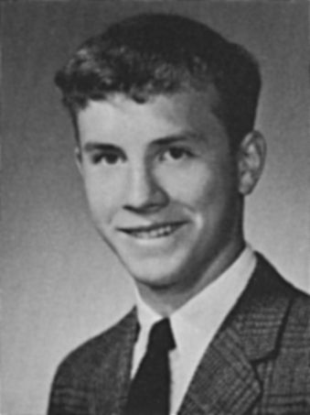
Kevin Kane
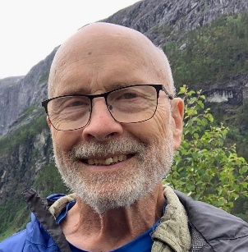
HALLOWELL - Kevin Kane, beloved husband, father, and grandfather, died peacefully after a brain aneurysm on February 6, 2026, surrounded by family. Kevin embraced life and lived it with exuberance, joy, kindness, generosity, and a deep love of the outdoors. His laugh was infectious; his garden was magical and productive. He was curious, passionate, caring, contemplative, and a little mischievous, too. Kevin was born in Centerport, New York, the fourth child to parents Daniel Hipwell Kane and Helen Shirkey, on February 16, 1949. An excellent student, he graduated salutatorian from Harborfields High School in Greenlawn, New York in 1967. He earned a bachelor’s degree in art history from Dartmouth College in 1971, where he met his first wife, Judith Anne Shagoury. The couple married in Shelburne, NH on October 24, 1970, before moving to New Haven, CT. They both attended Yale School of Medicine; Kevin graduated with an M.D. in internal medicine in 1975. Kevin and Judy later moved to Maine, where he began practicing as an internist and primary care physician at Kennebec Internal Medicine in Augusta. He was known and respected for the compassionate care he provided for nearly forty years. Kevin and Judy raised two wonderful children and became active members in the Hallowell community as volunteers for Vaughan Woods, the Kennebec Land Trust, and more. Kevin remained devoted to Judy until her death in 2012. In 2014, Kevin met Mary Simpson, also of Hallowell, at a community chorus rehearsal. The two shared a love of music, travel, and nature, and were married at the Vaughan Homestead on July 28, 2018. Together, they were active volunteers at the Unitarian Universalist Community Church of Augusta, where they participated in the orchestra and choir, helped to organize their Saturday Breakfast program, and joined their many social justice missions. Kevin never shied away from hard work and loved to help others whenever he could. He enjoyed exploring the wilds of Maine and beyond, always eager for a cross-country ski in fresh snow or a swim - no water was too cold for him, it seemed! He and Mary were active as land stewards for the Kennebec Land Trust and volunteers with Hallowell Conservation Commission. Following his retirement in 2018, Kevin and Mary enjoyed many adventures and lots of travel. They canoed the Allagash, cruised the Danube, and climbed Machu Picchu. Just as exciting were visits to their children and grandchildren. He is survived by his wife, Mary S. Kane, of Hallowell; his son Nolan Kane, his wife Sarah, and their children Hazel, Ash, and Elias, of Boulder, CO; daughter Ailene Ettinger and her husband Bob and their children Roger and Charlie, of Seattle, WA; step-daughters Julia Vattaso and Marguerite Coy and their husbands and children, and many cousins, nephews, nieces, and others that make up a large and adoring extended family. Kevin cared passionately about conservation, history and preserving Maine’s natural places for us and future generations to enjoy.

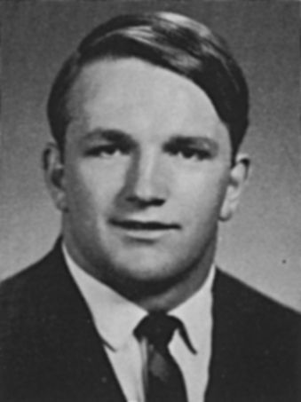
Bob ‘Leo’ Kelcourse
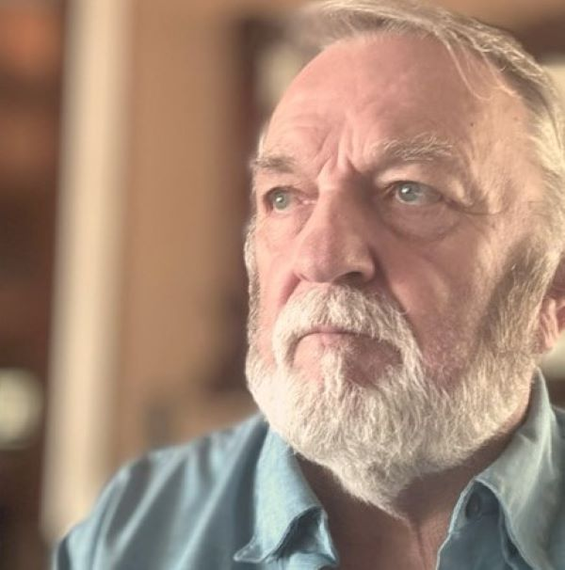
Bob “Leo” Kelcourse ’71 died July 17, 2024 in Clearwater, Florida, of complications of pancreatic cancer. Classmate Jim Rager reports that he had spoken to Bob twice in the preceding weeks, once just after the biopsy was performed and again when results were in. While the prognosis was not good, he was full of fight and even promised to record one last rendition of “Great Balls of Fire” for the class. He was an active student: a member of Phi Delta Alpha/Phi Delta Theta and participant in student workshops and the Tucker fellowship. He also played football and lacrosse. As an alumnus, he interviewed prospective students and was an Alumni Fund agent for fraternities and sororities. He is survived by his wife Olga, and children Hannah, Lisa, Mark, and Michael.
Remembrances
Rich McFadzean-
Our Friend and Roommate: Bob "Fat Leo" Kelcourse
Big...Bob was a big guy, with a Hulk-like body, a neck the size of a tree trunk, a big personality and, most importantly, a big heart.
I was Bob’s roommate for our first 3 years at Dartmouth. I’ll never forget first meeting Bob and wondering if I’d ever be able to decipher that Boston accent. I was from the suburbs of Chicago; and let’s just say I was a little more introverted than Bob and, like many of us, not sure just what I was doing at Dartmouth. Bob didn’t waste any time embracing me and the Dartmouth experience. We had football in common; and it didn’t take long to realize Bob would be a great friend, a great footballer, an incessant and talented entertainer and a totally unique individual.
Bob was a great football player. He was the best middle guard I ever played with. Exceptional speed, a nose for the ball, a hard hitter and a positive “let’s do it” attitude. Just the kind of guy you wanted as a teammate.
He also had “skinny calves” and knees that just didn’t hold up over time. It was one of Bob’s big disappointments. But it didn’t slow Bob down otherwise at Dartmouth.
Some may not recall, but Bob was a talented lacrosse goalie. Never having played, our freshman year we tried out for the lacrosse team. Bob quickly developed into our best goalie. We all know Bob was fearless, so Bob didn’t have any trouble getting in the way of that hard, rubber ball in the net. He was at his best (and in his glory) making a save and then personally taking it down the field to the opponent’s goal where he’d unleash a shot.
I never saw one of our opponents step in front of Bob on these occasions. Our opponents came from good schools, and so they were pretty smart. They would have been flattened by a 225 pound speeding missile. The big guy could fly.
Bob was a talented entertainer. I remember going to the Hop and Bob sitting down at the piano there and knocking out a series of “greatest hits” from the 50s and 60s. Just like that, he had the place rocking. I came to learn that Bob had been playing bars and clubs while in high school as a member of The Aladdins. (He looked great in the turban. The Toucan on the shoulder would come later.) [See photo below] He played the piano, guitar, accordion, drums and whatever else and loved to sing as well. And the best part, he loved to share these talents with everyone. No coaxing, he was really good, and he loved entertaining and the attention.
Bob was also an accomplished prankster. It didn’t take long for me to become one of his “victims”. I was always forgetting my key to our top-floor room in New Hamp. I had learned that I could go next door, exit via the window, and carefully amble across an 18 inch ledge to get into our room by removing the screen and entering through the window which was usually open. No big deal, except we lived on the 4th floor, so it was sort of dangerous.
One day, having locked myself out of our room, I was executing this “backup plan”. Unfortunately, Bob had returned while I was navigating the ledge and greeted me from inside our room while I was on the ledge outside our window. Bob had great fun ‘pseudo-lunging” at me with his hands raised from inside the window as if he was going to shove me off the ledge. All pretend, of course, but it took me a while to get over. Bob was just being entertaining; and as we all know, there’d be a lot more entertainment to follow.
Bob was an accomplished interior designer/decorator. Sophomore year, we moved downstairs and Bob Peter’s joined us as roommate. Leo found some beautiful, weathered barn wood soon after we had moved in, and we paneled our entire living room. With the addition of the red, flickering light bulbs, we were ready to party; and Bob was ready to entertain.
Bob loved a good debate. I remember attending a session at the Top of the Hop where Wally Ford was discussing equal rights for Afro-Americans during an open forum there. Bob asked a question or two; and I think Wally was a little intimidated by Bob, a large white guy with a different perspective on some of the issues. But you know what, Bob and Wally became friends after that. Maybe not “besties,” but they respected each other and always greeted each other when their paths crossed. After their initial “encounter”, Bob reached out and made sure Wally understood it wasn’t personal or race-based, just a different point of view.
Bob had a heart that was bigger than the rest of him. There are many stories where Bob’s heart shone bright. I don’t think anyone can share them all; but for me, Bob was always there when I needed him to brighten the day. Yeah, we had disappointments; but we had many more good times and lots of pure, unadulterated fun. If a girlfriend broke up with you, he’d be there sharing: “Girls are like trolleys. If you miss one, there will be another right behind.” Though there were no trolleys in Hanover, and dates could be hard to come by, Bob had a way to make you laugh at your situation and yourself and to move on with life.
Yes, we had our “fumbles;” but with Bob he was always looking ahead to “first and ten” and “let’s go”.
“Bob may not have been the meanest guy in town, but the meanest guy called him up every day to see if they were still friends.” He liked this saying, and we shared it pretty much every time we talked. Bob wasn’t mean at all. He was big, bad and beautiful. Big, yes. Bad, maybe if you played on the other side of the ball against him. Beautiful, yes, particularly if you loved to be entertained by an extrovert with many talents and a heart of gold.
Like many, I will miss him. I was blessed to know him, to love the guy and to call him my friend for all these years.
A footnote: The nicknames – I’m sorry I don’t clearly recall where the nickname “Fat Leo” came from or who coined it. But by sophomore year, we all had to have one and I’ll always love “Fat Leo” and “Eats” Peters” and even “Sheik”. My only regret: we never got jackets with our names on the back, like the Pharaohs in American Graffiti or the Pink Ladies in Grease. Seriously though, “Fat Leo” stuck because it was perfect for this guy whose middle name is Leo and who has always been bigger than life. [Bob Peter's NOTE: We did get jackets with our nick names on them; and the three of us would walk down the sidewalk with “Eats” in the middle.]
Barry Brink-
I did not know Leo well at all … We were teammates and fellow defensive linemen for his time on the team. We had no contact outside of football, but would say hello when we passed.
I did have a special moment with Leo at one of our various reunions. We sat next to each other at a dinner in the Bema and got into talking about our football experiences. I told him, something I had rarely mentioned, that I really did not enjoy playing football. I found it to be a lot of work without much pleasure, and that my favorite thing about football was sitting on the bench after being removed from the game during fourth quarters, and relishing the conquest. When I finished, Bob actually told me that he had known this … I was stunned that he had that insight, and I took it that he knew because he loved playing the game so much.
A special moment of reflection with a special person.
Tim Risley-
Radaks let me know about the passing of Bobby and I appreciated “Eats” kind words.
Leo was the first person I met after getting off the bus and dragging my suitcase and my little metal trunk to New Hampshire Hall. He and Rich McFadzean were across the hall…Bob introduced himself as did I….it took a bit of concentration to work through the hills of AR (Arkansas) to South Boston. I allowed that I was a tight end…he said he played ”god”...having to explain to me that it was the position between the center and tackle…we joked about it for 50 years.
Leo was “my friend “and a “take it to the limit personality “. We had some great times and did some things we shouldn’t have but God was kind to us both and let us grow up.
Schlenker and David Meeker were in my wedding to Ronnie Ann in August of’71… the other 2 Dartmouth representatives were Kelcourse and Flea (Mike Roberts). They showed up in northern AR, lost and very concerned that 2/3 of the vehicles were pickups and they all had gun racks in the back window, but a few beers and a little smoke settled them down….so. glad they came.
Leo Kelcourse with that fake bird on his shoulder…. will miss him...we all will…he was “one” of us
Go in peace…Bobby K
Jim Wallace-
Mostly because I messed up my knee in the first week of Freshman tryouts and spent from that day until Christmas walking around with a cast from my right ankle to my hip, I did not get a chance to meet most of you our freshman year. That Spring was spent in a tiny workout room above the basketball court trying to bring that leg back to working condition. Consequently, I was not a part of the fun and experiences most of you can reference.
However, the name and growing legend Bob "Leo" Kelcourse was infamous and widespread. His reputation was all over campus and I knew some of the stories. Unfortunately, we did not have the opportunity to become good friends, but we would speak in passing around the campus.
My first significant opportunity to know Bob did not come until I had my Quintuple bypass surgery. It was Bob who reached out to me and we had several talks about going forward. Those talks showed a wonderful, kind soul. When we were in Hanover as a group and spread Darrel's ashes on the fifty-yard line I was walking up the hill from the tent to dinner in the Hop and had an opportunity to walk with Bob and Olga. At the time Bob was having trouble walking, but even then, Bob was lively and we had a great walk. It was the last time I spoke to Bob. A great guy has left us, too soon.
Mike Roberts-
Jim [Rager] you are right, we all love Leo larger than life. He was a character great heart with a sense of humor. Fortunately, we all still have our Bobby Leo stories and memories.
Be Well. Bless you all
Mark Stevenson-
I met Kelcourse in the summer of 1967 just prior to coming to D. I was the co-captain of the North squad for the Agganis Bowl for Eastern Massachusetts. My coach was the head coach and installed me as the starting center. So on the first play from scrimmage, the nose guard for the South blew by me so fast he made a QB sack on a dive play. Sweet Jesus!!
The first half was sheer misery for me, trying to contain the lightning-fast NG. I gained a little self-respect back in the second half but after the game the NG came up to me and introduced himself as Kelcourse and he said he would see me at Dartmouth. Great!! But in honesty, facing him at practice made me a better center and of course a hell of a lot quicker.
We didn't socialize in college, he was out of my league, but I did connect with him in the late 1990's as my father-in-law lived in the next town over from Safety Harbor and along with wives, did enjoy a dinner together. He didn't change and was the type of person that could mix and entertain in any sort of a crowd.
Joe Jarrett-
Fat Leo and I had a belligerent relationship from the get go. On one of our freshman football bus trips, might have been Holy Cross, he and I sat together. I'm not sure who started it, but while we were supposed to be studying, one of us started using a yellow magic marker to highlight an important sentence or two in whatever book we were studying. Well, one of us, not sure which, started highlighting the sentences in the other person's book, which went on for a while. Then the boiling point was reached; we started highlighting each other's hands, then faces, and then all heck broke loose. We had to be separated by Cactus Jack and placed under strict surveillance in the bus. Of course, that little episode was the start of a four-year friendship of mutual respect.
We played freshman lacrosse together, he a goalie who had never held a lacrosse goalie stick in his life, and me a center middie. During a game against Harvard, one of their prissy little attack men was drilling goals on Leo left and right. Finally Leo had enough, and he charged out of the goal, wielding his goalie stick like a scimitar and attempting to separate the prissy little pencil neck's head from his neck. He almost succeeded before being restrained by teammates and officials. One of my very best memories of Leo...he was discharged from the team shortly thereafter.
However, we thoroughly enjoyed pranking each other. I was under the weather in my dorm room in 410 Fayerweather and Fat Leo came to offer condolences and to wish me good health and a speedy recovery. On the way out, he generously lit and tossed a couple of cherry bombs into my room. BLAM BLAM!! I guess that was supposed to hasten my healing. The tables turned when he was sick in New Hamp and I went to offer my condolences. He had been puking his guts out and had a waste basket half full of puke. The lit cherry bomb I dropped in the waste basket on the way out exploded nicely, splattering his entire room. But you could never get the best of Leo.
He got me back in the basement of Beta when we were engaged in a game of pong. He waltzed into the basement wearing his patented house robe and slippers, a stuffed parrot on his shoulder, and a bandelier of darts across his massive chest. His aim was accurate and the dart impaled my index finger middle knuckle of my beer holding left hand...I didn't spill the beer but my finger hurt like hell.
He and his family visited us here in Myrtle Beach a number of years ago. It was great to see him again.
He was bigger than life, street smart, tough as nails, a talented musician, generous to a fault and a ferocious and wonderful friend. We will sure miss you, Leo. RIP, old pal.
Bob Peters-
For many months now (perhaps it’s been a year or two) I have been ‘meaning’ to give Leo a call, and now it’s too late! And I’m sorry about that.
I don’t remember when or how Bob Kelcourse (Fat Leo), Rich McFadzean (Sheik) and I (Eats) became close friends; but it was during our freshman year because we chose to room together in New Hampshire Hall when we were sophomores. Fat Leo was the life of the party at New Hamp! He had a small electric piano, and on weekends after we had drunk one too many 7 Ups or Pepsis, Leo would play and sing contemporary songs. Students from other dorm rooms would come in to hear and enjoy the festivities. He was a talent. He was also one hell of a football player; but he had a weakness, his knees; and his knees finally did him in. I still remember him being carted off in great pain on a stretcher to Hitchcock Hospital. His inability to continue playing football hurt him deeply.
He wasn’t the best student, but that wasn’t because he wasn’t intelligent. It was because Leo loved to have a good time! I also think that Leo’s parents may not have stressed getting an education like mine did because Leo was the only one of six children to get a college degree. I hasten to add, however, that Leo’s older sister Helen became a nurse, and back when she graduated from high school, that was one of the few doors open to a young woman. Leo’s oldest brother was also a plumber, and he made more money than many Dartmouth grads!
I hadn’t planned on doing so, but I also spent the summer of 1969 living at Leo’s house in Quincy, Mass. I had gotten a work study job that summer in a social welfare office in Dedham, Mass. and needed a place to stay until I found an apt. Long story short, I spent the summer living with the Kelcourse family, and it was the happiest summer of my life. Leo’s family had their problems too, but his parents treated me like I was a fifth son; and his brothers and sisters treated me the same. Well almost, because Leo’s sister Nancy and I began to date that summer, and we continued to date for another year or so after that. For the most part Leo’s family also got along and enjoyed each other’s company. My family was different because my dad was easily angered. I was too!
Long story short, things did not go well for Leo and I our senior year at Dartmouth. I had two knee injuries during the 1970 season, and Nancy and I went our separate ways. I started drinking way too much after the football season ended, and Leo was getting high on other things. After we graduated, I went to New York City (where my wife and I still live) to attend law school; and Leo moved to Florida not long after we graduated. Leo and I reconnected some years ago, and I’m glad we did. Leo was still Leo, but as Dan indicated he may have had a change of heart where religion was concerned. He told me that his daughter had become a Christian and that he went to church with her. I was happy to hear that and hope to see him again in a better place!
PS Bob had an older brother who also played football, and the two of them lifted weights together. Their father had also boxed when he was a young man. All this is to say that Leo was a force to be reckoned with on the football field!
Dan Radakovich-
Dear Brothers (and especially you former "Thumpty-Dumpters"!),
My sincerest sympathies to all of you (and us) on Leo’s passing. I know that a number of you (especially "Eats") were close to Leo for many years. Early last year and (almost) "at random" Leo and I had a series of 5 or 6 very pleasant email exchanges and telephone conversations covering a wide range of subjects including-but not limited to-football; our Families; our Faith journeys; economics and even Politics. Although we had some disagreements on the latter subject our discussions and "disagreements" were quite cordial, respectful and thoughtful most of which are, unfortunately, missing from our society today. I just brought up the emails and re-read them upon hearing of Leo's passing. I am especially thankful for them since Leo and I had very little contact over the years (hence my reference to: "at random").
In passing, it brings a smile to my face to picture that TOUGH guy with a HUGE CHEST and skinny little piano legs!! He was so fast, quick, strong, fearless and focused, and, OH MAN, could he hit!!! Although Skibitsky was certainly no "walk in the park" Leo was probably the one whom I most dreaded going up against. Had he not had "the curse" of bad knees. . . .Who Knows?! He was a FORCE!** Memory Eternal.
Hope that all of you and Yours are well. Although I know that he'll be greatly missed by his Family and many others. I am confident that Leo is just fine!
Brad Houser-
I remember Bob had very quick feet and a strong upper body. He could definitely play football. And even better than his football was his piano playing - what a talent. We were never close but I recall a chance run in with him many years ago in Safety Harbor FL. We chatted and talked for 20 or 30 minutes and agreed that we would follow up with each other. Unfortunately that never happened.
______________________________________________________________________________
Bill Kennedy
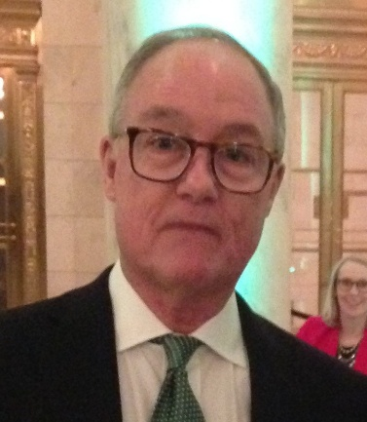
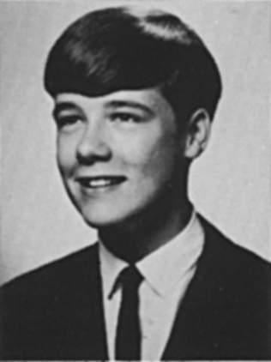
Bill Kennedy, 71, died in New York City on June 18, 2022, leaving his three sisters to grieve for
him, along with a wide network of friends and family. Bill was the son of a career military officer. The family moved often, and Bill thrived, adapting smoothly to each new school and locale. Two of his middle-school years were spent in Paris, where Bill learned French and perhaps acquired some of his attributes. For example, Bill was debonair; he lived life with élan; he loved haute cuisine and the arts. Bill would return to France many times – for junior year abroad in Strasbourg; later to escort his sister and her spouse around Paris; and just because. At Dartmouth College Bill minored in French, and one of his cherished memories was to have been an assistant to the renowned professor John Rassias. From a very young age, Bill loved cars. He always knew all the brands, all the models, all the years. Bill also loved words, ideas, logic. He had an astonishing memory for detail, able to retrieve for example, decades later, the family phone number in Norfolk, Virginia. He took pride in doing the New York Times crossword puzzle in ink. After college Bill went to Georgetown University Law Center, where his intellect, logical mind, and prodigious capacity for detail made him a natural attorney. Despite the heavy course load, he still made time for the arts, participating in Gilbert and Sullivan productions with fellow law students. After law school he embarked on a career as a corporate attorney in the auto industry – another natural fit. He enjoyed working for DeLorean Motor Company in its start-up years, and later for Rolls-Royce. All his life, Bill was the go-to person for advice on buying a car. And he was very choosy about his own car purchases. More than once he flew to another state in search of the
perfect car.
Bill was generous and thoughtful in ways large and small. He frequently welcomed friends and
family to his New York apartment. He attended absolutely every family function possible, including the weddings of faraway cousins and of the children of his friends. He got his sister and young niece tickets to a filming of Sesame Street and treated others to Broadway shows and concerts. He borrowed a Rolls-Royce to chauffeur his sister and her husband on their wedding day. One dear cousin had a copy of Life magazine from the 1950s, cherished because it featured a story about her lakefront home with photographs by Alfred Eisenstaedt, but crumbling from age and use; Bill presented her with a pristine original copy of that issue of Life, moving her to tears.
In retirement, Bill enjoyed further pursuing the arts, including joining the Amateur Comedy Club
in New York, acting regularly in its productions and serving on its board. Acting gave him joy. So did his second home in Vermont. Bill enjoyed the bucolic country life as well as the city lights. He remained an active member of the Dartmouth Lawyers Association. When Bill was diagnosed with prostate cancer in 2009, he managed to call upon deeper reserves of strength and humor, persevering stoically through many visits to “Club Sloan” and sending his sisters occasional “Medical Reprise-a-thon” emails with updates on his journey. His doctors admired his matter-of-fact grit and dry wit. So did his family and friends. We are profoundly grateful to the oncology team at Memorial Sloan Kettering Cancer Center in New York, without whose expertise Bill’s
life would have been cut short much sooner. Now his journey has ended, and he can rest at last. We will all miss him deeply. A memorial gathering is being planned. Gary Brooks '70

Remembrances
Greg Fell 7/3/2022
Saddened to read of Bill Kennedy's passing. Bill was a regular at the annual Class Dinner in NYC and the Mandel Dinner most years. In addition to his home in NYC, he owned a property in Fairlee, Vermont. He was always current on local valley news and gossip. He has some great stories in his contribution to the 50th Reunion Book, notably his acting as a "seat filler" at the Academy Awards one year and a flight on the Concorde. After notice of his passing, I sent a mail to Jim Rager and Roger Prince that I thought sure I saw him across the Class Tent at Reunion last month and meant to catch up with him. It must have been a vision, or just a memory, as he was not listed as being in attendance. Great guy, will miss him.
Lewis Harriman III 7/9/2022
Those of us who hung around the Romance Languages Department between '67 and '17 knew that Bill was definitely one of the cool kids. After serving as a drill instructor in French for three years, Bill was one of three undergraduates to be selected by Rassias to be fully responsible for teaching Introductory French—the first time in history that *any* undergraduate had been allowed to teach a formal, full-credit course at Dartmouth.
David Aylward-
We became lifelong friends in our shared love of French, John Rassias, and Strasbourg. Bill was a brilliant and sweet guy.

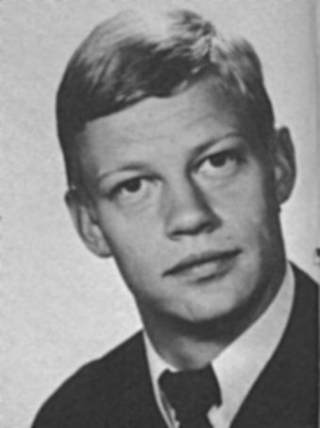
Gunnar Klintberg
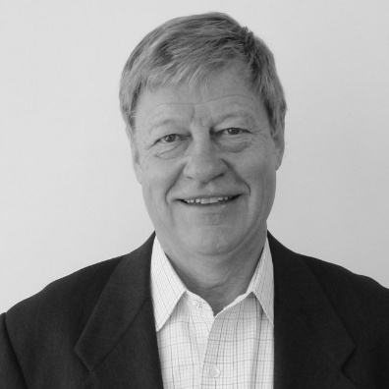
Gunnar Elias (10/16/1948-4/28/23). It is with profound sorrow and love that family and friends mourn the passing of Gunnar Klintberg after a three year battle with the incurable ALS. Gunnar was born in Stockholm, Sweden to Lars-Gunnar Klintberg and his wife Gunborg. After completing school in Sweden, Gunnar attended Dartmouth College on a basketball scholarship (1969-1972) and earned a BA in International Political Science. Exceptionally talented in languages, Gunnar was accepted into the prestigious Russian language Interpreter School (Tolkskolan) in Uppsala for his military service. Simultaneously he completed his master’s degree in Russian and Eastern European Studies from the University of Uppsala (1973-1975). Gunnar began his business career with the Axel Johnson Group in Stockholm, trading with Eastern Europe. In 1976 he became General Manager of the Axel Johnson Moscow office. After three years, he was transferred to the NYC office as Assistant to the President (1979-1982). Gunnar then joined the Nordic American Banking Corp (1982-1986) in Corporate Finance. In 1986 Gunnar and a partner formed Holberg Incorporated, a private equity firm invested in various companies, primarily in fast food distribution and parking services. From 1997 to 2008, Gunnar served on the Boards of Thule Inc, AmeriServe Food Company, The Swedish American Chamber of Commerce, and Standard Parking. He also served on the RTM of Old Greenwich for many years. Gunnar was an avid reader – especially NYT – of current and foreign affairs. A frequent hitchhiker in the early 70’s, he was fortunate to be picked up by his future wife, Jamie, in San Diego, CA. Friends and family will fondly remember all the dinner parties Jamie and Gunnar hosted. Gunnar loved people, his cheerfulness and enthusiasm were contagious. Gunnar is survived by his wife of 47 years, Jamie, brother Bengt (Kersti), uncle Leonard, niece Jenny (Matt and daughter Kaleigh), nephew Johan (Josefin, daughters Lily and Julie), niece Jessica (Gabriel), brother-in-law Lance (Ina) and many dear friends and extended family.

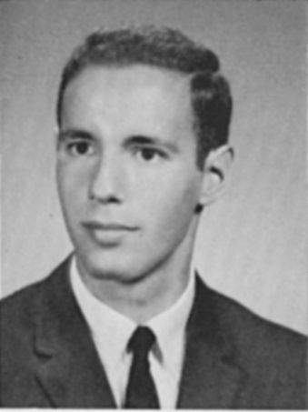
Bob Lider
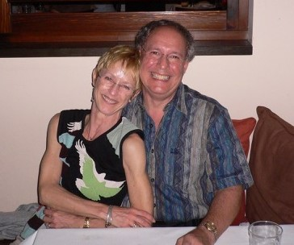
The following is a letter from Lisa Lider to the class, memorializing the life of her beloved husband and our classmate, Bob Lider.
As many of you know, my late husband Bob Lider had tremendous love for his College, his Class and his classmates. I often teased him that Dartmouth came first. I remember the 45th reunion. Bob changed OUR holiday plans to fit the reunion schedule. Bob’s life was so deeply intertwined with Dartmouth that any account of his life must surely highlight his 50 plus years of engagement with the College and Class. Thanks to Bob, I have shared in the experience. Having grown up abroad, where you went to school and left, being with you all was quite a learning curve for me. This is a moment for me to say a few words, about his death, in the form of an obituary, and as a brief letter to his beloved classmates.
We were in Venice, Italy where I have immediate family. Bob loved Venice and was very proud of his Italian passport and to have Italian relatives! The day started like any other. I left earlier and our parting words were, “See you at the beach”. Bob was at the Lido when he went into sudden cardiac arrest. This was quite a shock, completely unexpected, and occurred just two months after the 50th plus one reunion in Hanover, where Bob spearheaded the activities as he had for the 45th Reunion. Although Bob suffered from both sleep apnea and AFIB, neither his cardiologist nor I ever imagined it would end as it did.
To remember Bob at the “50th plus 1” Reunion in June is heartbreaking in so many ways. To see the photos on the website is to remember Bob at his most typical: table hopping at lunch, or directing undergraduate helpers at the Class tent.
Jim Rager: “Bob was smart, driven, and an accomplished lawyer. We knew him as a man of action, always willing to step up and do the hard work on behalf of the class and Dartmouth. But I will remember him most for his generosity, kindness and caring spirit. His efforts to the benefit of us all, the 50th + 1 reunion being but one example, were motivated by his love for us. RIP, dear Bob. You were a loyal son of Dartmouth, a true friend, and an exemplary human being. We will miss you."

For those who didn’t know him, Robert Yamins Lider was born in Newton, Massachusetts, son of a Dartmouth ’43 whose own Dartmouth experience was interrupted by service in World War II. Bob attended the Rivers School outside of Boston, which didn’t have a squash team, but Bob was able to land a spot on the Dartmouth freshman squash team as a “walk on.” That a totally polished player could appear out of nowhere was baffling to everybody at Dartmouth, given the tight-knit prep school squash world of 1960s New England. Bob admitted to his coaches how he did it, and in later years, Bob regaled friends with the story: he had taken private lessons at the Harvard Club of Boston from the great squash master Mohibullah “Mo” Khan.
At Dartmouth, he gained some fame and perhaps notoriety as the “Indian” mascot at Dartmouth football games. In the classroom, Bob excelled, on the dean's list, with a major in government. But he was also a gifted student of foreign languages. He had never been outside the U.S. before entering Dartmouth, but he qualified for advanced French language courses. He had great admiration for Prof. John Rassias, and spent two terms abroad in Strasbourg and later at Caen and became a French language tutor while on campus.
In 1974, Bob graduated from New England Law and began what would be a nearly 40-year career as an international tax lawyer, first at Price Waterhouse and later at Westvaco Corp (now Mead Westvaco.) In 1979, while working at Westvaco in New York, Bob and I met on a blind date, arranged by our mothers who were roommates in college! Our mothers spoke once a year around the Christmas holidays. Bob had recently moved to NY from California, and I from Milan Italy. I had been a ballet dancer at La Scala in Milan and Bob was the first American I ever dated! I grew up speaking English at home, but Italian with everyone else! Needless to say we both had a lot to learn. I remember waiting for Bob to come back after he said “see you later.” We married in 1983.
Meanwhile, Bob joined Citibank in New York and was later transferred to Washington, where he worked on the tax implications of the NAFTA trade negotiations. Upon returning to Citibank headquarters in New York, Bob found himself involved in a highly contentious situation involving a high-profile client: Donald J. Trump. As Bob recounted in his reunion-book essay, “Once upon a time, Citibank in its wisdom concluded that financing Donald’s growing business empire would be a sound strategic move.” Citibank funded Trump’s acquisition of the iconic Plaza Hotel in Manhattan, the Trump Shuttle and real estate on Third Avenue. As Bob wrote, “It was only a matter of time before the Trump Organization found itself in a dire financial situation and in breach of its loan agreements with Citibank…” The Trump Organization declared Chapter 11 bankruptcy on the Plaza hotel in 1992, for example.
Bob transferred to Singapore with Citibank in 1998 and we lived there and in Hong Kong for the next 16 years. In 2009, Bob retired from Citi but was recruited by JPMorgan to be Regional Tax Counsel in Singapore, where he lived until 2014. Bob was thrilled that he could also fulfill a life’s ambition to teach, as an adjunct professor at a Singapore university.
As some of you know, we were still living in Singapore when the Class of ’71 convened its ”Turning 65” Mini Reunion hosted by Jim and Yola Rager in 2014. We knew we needed to return to the States, and after Singapore, to a warm climate, so Naples Florida it was. We actually decided then and there to purchase our next home.
Bob has always been very active in the Class of ’71, and after returning stateside he spent five years as Class Secretary, in addition to serving twice as Reunion chair and was involved in interviewing prospective applicants to Dartmouth. He was also one of the most generous members of the Class.
As I am a real city person, having been born in Manhattan and grown up in Milan and having lived in DC, Singapore and Hong Kong, moving to Naples was a difficult adjustment for us both. After seven years we agreed it was time to move back to a city. In July of 2021 we moved back to Washington DC. Except during Covid, when traveling was impossible, Bob and I have spent every summer with my family in Venice Italy. Bob is also survived by his two sisters, Jani and. Carol, who both live in the Boston area. He is also survived by numerous nieces and nephews.
Finally, I want to say how grateful I am for all the tremendous support from the Dartmouth community and from so many ‘71s in particular. You have always been there for Bob, in person, in spirit and in gestures large and small.

Remembrances
Ted Eismeier-
For many of us, the 55th Reunion will spark memories of Bob, the driving force behind our 45th and 50 + 1 reunions. Bob and I worked closely together when he was Secretary and I was Webmaster. I will remember his kindness, his assiduousness, his devotion to Lisa, and his passion for Dartmouth and the Class of 1971. Just before the 50+1 Reunion, Bob and Lisa gifted Betsy and me a vintage book about the history of Dartmouth. We treasure it.
David Aylward-
Bob was a force of nature and an enormous contributor to the connections and friendships within our class. He had a way about him that one just thought you had to say “yes.” I will never forget his recruiting me to be the editor of our 45th reunion book. He called me out of the blue and said that the class leaders had decided that because I had been the editor of The D, I should be editor of the 45th book. In retrospect, neither of those statements makes any sense at all. There is no connection between editing a newspaper decades ago and a reunion book. And no college class does a 45th reunion book. But we did, and it was exactly what Bob intended: a warm-up and contribution to the momentum for our 50th reunion and book. He was funny, warm, and caring.

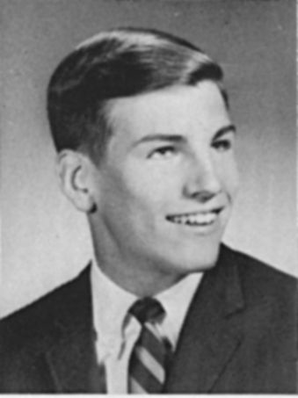
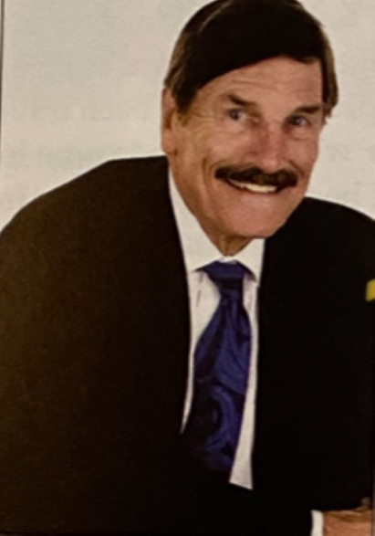
Harold ‘Hal’ McCulloch
Born June 24, 1949, to the late Gloria L McCulloch and Harold Young McCulloch, Sr. in Newport News, VA.
“Hal”, as he was affectionately known, attended Public Schools where he studied Latin and excelled in Track and Field throughout his High School years. Fitness and health were his passions. He also was an avid reader. He never missed a day running or swimming as a teenager. Later as a young adult, he never missed a day running track until after college. After High School, Hal attended Dartmouth College, in Hanover, New Hampshire and graduated with an A.B. Degree in Classics, and as the Class Summa Cum Laude. He then attended the University of Michigan, at Ann Arbor, where he received a Ph.D., in the Classical Studies of Ancient Greek and Roman History. Hal later received a M.B.A., in Business Management at Ryder University, Lawrence Township, NJ, while working as Associate Dean of the Honors Program in the College of Literature, Science and the Arts at Princeton University, Princeton, NJ. From there, he became President and Senior Vice President of DeVry University, Medical Division in Caribbean.
After retirement, Hal moved to Pooler, Georgia in June 2014 with his wife, Veronica. He began studying the Bible with Jehovah’s Witnesses in 2016 and symbolized his faith and dedication by water baptism on April 2, 2017, in Orangeburg, SC. He loved and cherished the wealth of information he received while attending Meetings, Assemblies and Conventions. He enjoyed wholesome gatherings with our Friends. Hal also enjoyed his worldwide association with our brothers and sisters.
Hal was a “gentle” man having a mild spirit. He showed a genuine brand of love and interest in people. He, loved children! He always had a story to tell, which made you laugh. He leaves behind: his beloved wife, Veronica McCulloch; as well as his four Stepdaughters: Dana (Nieland) Bynoe, Lauren (JP) Butler, Gloria Lewis and Melanie Lewis, two brothers, Brian McCulloch, and Jeffery McCulloch; one sister: Gloria Staley, and a host of grandchildren, great grandchildren, nieces, and nephews.
Remembrances
Ted Eismeier-
I knew Hal very well at Dartmouth. He and Joe Cecere were roommates on the first floor of Fayerweather and I lived on the third floor. What I remember most about Hal was his enthusiasm-- for the Classics, for classes in Government we took together, for running, for events, for conversation, for friends. We kept in touch sporadically over the years. Betsy and I spent time with Hal and his wife at the 45th Reunion. I wish we had kept in touch afterwards. His wife's memorial for him describes a man with the same infectious enthusiasm who has found peace.

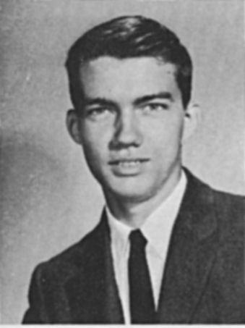
Colby Morgan
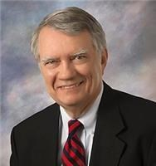
Colby Shannon Morgan, Jr., passed away on May 24, 2022, at the age of 73, in his hometown of Memphis, Tennessee. He was a loving husband, father, friend and colleague, embraced by loved ones as he took his final breath.
Born on March 29, 1949, in Marshalltown, Iowa, Colby was raised in the Midwest and Northeast. He lived most of his formative years in Pittsfield, New Hampshire, becoming a young community leader and a standout at the town's high school. Colby graduated from Dartmouth College in 1971, after which he received a juris doctorate from Vanderbilt Law School in 1974.
It was at Vanderbilt where Colby met the love of his life, Leslie. They wed in her hometown, Memphis, Tennessee, in 1975, where they would eventually settle down and spend nearly all of their 47 years together.
Colby's legal career included cherished years of service with the Jackson Lewis national labor & employment law firm, the FedEx and Holiday Corporation legal departments, and private practices in New York and Memphis, including Apperson Crump, PLC, Memphis' oldest law firm. During his 22 years at FedEx, Colby received several awards for his litigation successes, including the Five Star award-FedEx's highest honor-as well as multiple Bravo Zulu and "Star Rating" awards for outstanding performance.
Admitted to the practice of law in both New York and Tennessee, Colby would also be admitted in fifteen federal district courts, seven United States Courts of Appeals (including the D.C. Circuit Court of Appeals), and the United States Supreme Court. He was a member of the American Bar Association, Federal Bar Association, Federalist Society, and a Fellow of the Memphis Bar Foundation.
Above and beyond his career, Colby loved his church, community and country. He served as Chairman of the Memphis Civil Service Commission, Chairman of the Board of the Memphis Emmaus Community, Governor of the Tennessee Society of Colonial Wars, and State President for the Tennessee Society of the Sons of the American Revolution, for which he was awarded that organization's highest honor-the Patriot Medal-for his long, faithful and outstanding service. He also served on the boards of Christ Methodist Day School, Su Casa Family Ministries, Latino Memphis, and the National Hispanic Professional Organization. Valued for his prodigious knowledge, Colby was frequently invited by groups to speak on legal, historical and religious subjects.
Colby always strove to give as much of himself as possible. He will be remembered for his memorable teaching efforts, which included an unwavering participation with his wife in their President's Day program held annually at Christ Methodist Day School. For his part, Colby would dress up in full regalia to become George Washington, a memory that would endure for so many of the school's students. He will be remembered for his voice, particularly in song, singing in choirs from his earliest memories to his latest years. Whether in church, the Memphis Symphony Chorus, or the shower, Colby loved to sing. And he sang with valour and skill, often taking up solos in an impressive array of performances. And when not singing, many will remember Colby for playing his guitar and trumpet, often performing "De colores" at Emmaus sendoffs and the "Taps" bugle call during Memorial Day and other solemn occasions. In his more advanced years, Colby would also take up running, summoning the resolve to participate in three marathons. If ever there was doubt about his character in commitment and fortitude, any such notions were dismissed during this particular chapter; he finished all three marathons.
For all of his accomplishment and talent, Colby was a man for his family first and foremost. His love for his wife and three children never faltered. Whether coaching baseball, basketball, soccer games, or mock trial teams, leading Cub Scouts and Pinewood Derby races, imparting his voracious love of history with family trips to battlefields and other historical sites he loved, or simply making himself present at even the most nominal events of his children, so much of his life was imprinted by his familial dedication, a fundamental selflessness rooted in his core convictions and deep faith. With his passing, he leaves behind a triumphant example of conviction, commitment, wisdom and faith. He will be remembered and loved by those who were blessed to know him forevermore.
Colby was preceded in death by his parents, Colby Shannon Morgan, Sr., and Elizabeth Perkinson Robertson. He is survived by his wife, Leslie Morgan; two sons, Colby Shannon Morgan, III, and Jeffrey Michael Morgan; and one daughter, Sarah Morgan Ashey; four siblings, Charles Michael Morgan, Carol Morgan Taylor, Robert Lee Morgan, and Joel Stuart Morgan; and four grandchildren, Rebecca Cahill Morgan, John Jeffrey Morgan, Julia Smith Morgan, and Hannah Lukens Morgan.
Remembrances
Barry Brink-
Colby and I were among a group of freshmen who resided in McLane Hall, the middle dorm of "the Wigwams" back in the 60's. They were about as far away from campus as you could get, so the group of us got to know each other pretty well. I don't recall his roommate but I do remember that the ten or so of us were each from a different state. I always wondered if the administration did this randomly or on purpose.
Colby was from New Hampshire, and he invited a really homesick 17 year old to come home with him, since that classmate didn't have enough time to go back to his California home. He and his family treated me like one of the family for four days and gave me a glimpse of New England life. I never forgot their kindness.
Steve Brown-
We became good friends at Dartmouth and stayed in touch, albeitly sporadically, over the years and he was most definitely one of the "good guys"!
Peter Pratt-
His powerful example will live on and benefit immensely the many friends and family he touched in his life of generosity and service. The hill winds will remember his name

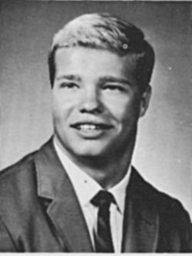
Bill Munich
Bill was born 26 Jan 1949. Bill graduated from West Geauga HS in Chesterfield Ohio which is 13 miles east of South Euclid. He was captain of the football and wrestling teams and on the track team years 2,3,4 for all 3 sports.
Nov. 28 1970 he married Jacquelyn Kay Moore, daughter of Mr. and Mrs. Clayford Moore of Chesterland. William H. Munich, son of Mr. and Mrs. William Munich of Chesterland (newspaper engagement announced in July 1970) marriage took place on Nov 28, 1970, His residence was Geauga County Ohio. At the time of his death he was president of Cranston Steel Structures in Woodland, California He died in El Macero, California on March 1, 2024. His family did not provide an obituary.
Remembrances
Jim Rager-
I learned a few days ago the sad news of the death last March of our classmate, Bill Munich. Since then, Alice Malone spoke to his wife, Marcia, to offer our support and condolences and had a nice conversation with her. Alice told me that Marcia is not doing an obituary and I do not think that Bill stayed in touch with many of our classmates, so few details are available at this time. Bill was a stalwart member of the 1970 Ivy football champions and a good friend to many.
Jack Burnett-
I'm very sorry for Marcia and family's loss, not to mention that of many of us who knew Bill. FWIW, Bill was a great, highly respected member of our Beta class of '71, starting in the fall of '68. He is known as a linebacker, but in fact his closest friends understood and loved the fact that he was super-smart, super-humble, and just mainly a very nice guy--which is really what it's all about in the end. As much as I am disheartened to learn of his physical passing, I am selfishly happy to be reminded of him and what a great person he was and will always continue to be in my memory.
Barry Brink 11/24/2024
Bill played L Linebacker on our 1969 and 1970 championship teams. He did not receive the attention that others on our starting defensive lineup did, but that’s probably because he played behind Fred Radke, ‘73 and myself. The opposing ball carrier was already on the ground before he would get to Bill … Only half kidding. Bill was a great teammate and a solid guy.
Tom Hancock 11/23/2024
Bill and I were part of the monumental time in Bourges, Spring of ‘69. He was such a solid guy—not just physically, but in character. Loved his smile!
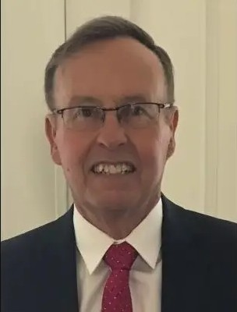
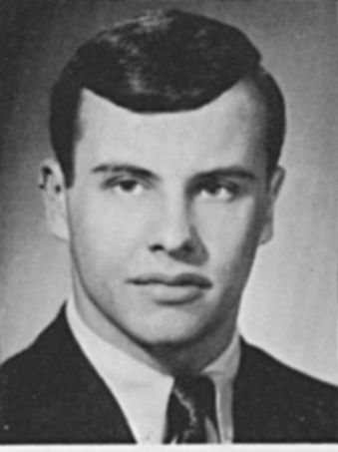
Kevin Murphy
Kevin R. Murphy, 75, of Milford, CT formerly of Newtown, passed away with his wife (Karen Karpie) and two children (Katie Hayward and Daniel Murphy) at his side on October 11, 2024. Kevin would want to be remembered not as the brilliant and successful trial lawyer that he was for several decades, but for the much more significant roles he enjoyed during his lifetime, as husband, father, grandfather (or papa as they call him), brother, friend, uncle, mentor, role model, neighbor and golf buddy.
Kevin was born on May 10, 1949, to Robert Murphy and Rose Mary (Hoehne) Murphy, in South Bend, IN where his father attended Notre Dame University on the GI Bill. He spent his boyhood first in Peoria, IL and then in Rockford, IL where he graduated in 1967 from Boylan Catholic High School, having excelled in academics and football. Kevin attended Dartmouth College, sight unseen, and graduated from Dartmouth in 1971. Like many students of his time, Kevin protested the Vietnam War, and he continued throughout his life to espouse progressive causes to further justice for all.
Kevin was a worker---he worked hard at whatever he did and it seems there wasn’t a job he didn’t do (paper route at 11 yrs old, busboy, waiter, jack hammer operator, foundry worker, school bus driver, landscaper, putting finishing touches on mannequins, driving artificial flowers to New Jersey grocery stores, and working in sales for General Tire & Rubber in NYC.)
In 1971, he enrolled in UCONN Law School where he met his wife, Karen Karpie, on the first day of classes, and they’ve been together since then. They got married and graduated the same weekend in May, 1977, and they worked seamlessly together as law partners (eventually at their own firm, Murphy Karpie Connelly & Sickinger LLC) and as life partners.
In addition to his wife, Kevin leaves their daughter, Katie Hayward of Milford and their son, Daniel Murphy (Ally) of Fairfield along with his amazing, cherished grandchildren, Max, Leo and Vivian Hayward, and Ava, Nora and Riley Murphy. His other survivors include siblings, Vincent Murphy (Debbie) of Caledonia, IL; Joseph Murphy (Jill) of Valrico, FL; David Murphy (Marcia) of Anderson, IN; and Mary Ann Cox (Gregg) of Rockford, IL. He also leaves
sister-in-law, April Karpie of Los Angeles, CA, and brother-in-law, Andrew Karpie (Irina) of San Carlos, CA. as well as 18 nieces and nephews and 16 (at last count) grandnieces and grandnephews. He was predeceased by his parents, and his beloved nephew, Xavier Murphy.
Even though Kevin had Parkinson's Disease, he never once complained, and while it slowed him down some in his later years, he did not let it hold him back from fully enjoying his grandchildren. He rarely missed their games and sporting events, and even played basketball and hit golf balls at the driving range with them this past summer, much to their amazement. Life will not be the same for them without him.
Kevin will be remembered by his colleagues as a fierce competitor with an unending desire to win, and he nearly always won, but he never once gloated about it. His courtroom skills gained him the respect of lawyers on both sides of the aisle, judges, marshals, court reporters, his clients, and even the clients whose lawyers lost to him. Kevin was known for his killer cross-examinations and logical, sometimes sarcastic but aways persuasive final arguments. Jurors loved him and often when a trial was over would approach him and ask him for his business card.
Kevin’s intellect was matched by no other and his wit and wry sense of humor was always on display. He was often the life of the party. He liked the New York Times, beer, golf, babies, ice cream, birds, especially cardinals, taking walks, snow falling at night, a tidy office, NYC, Murphy family vacations, the moon, the ocean, music, dancing (in a dad sort of way), but really what he loved best of all was hanging out with his family, who will miss him forever.

Jake Paul
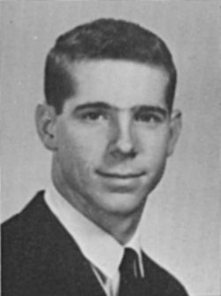
Charles Ralph Paul, Jr. (Jake) passed away peacefully on August 20, 2024. He is survived by his siblings Mary Anne Paul Durr of Montgomery, Alabama, Sarah Paul Owen of Gulf Shores, AL, and John Wade Paul (Amy) of Cincinnati, Ohio. Jake was preceded in death by his parents Charles Ralph Paul and Jane Faulkner Paul of Geneva, AL. and his siblings Martha Jane Paul Finlay of Albertville, AL. and William Joseph Paul of Geneva. AL. Jake graduated from Geneva High School (AL) in 1967 where he excelled in athletics. He then graduated with a degree in History from Dartmouth College in 1971 and served the Navy for two years at the Naval Material Command Headquarters in Washington, D.C. Afterwards, he attended the University of Alabama Law School receiving a Juris Doctor in 1976 followed by a master’s degree in City/Regional Planning from the Portland Graduate School of Urban Development,OR. in 1980. Following work in Portland and Palatca, Florida, Jake joined the Paul and Paul Law Firm in Geneva and later worked with the Gil Law Firm in Dothan. Throughout his life, Jake deeply valued the town of Geneva, its community connections, history, and people.

Remembrances
Dick Wenzel- 5/18/2026
Jake and I were on the freshman football team with lockers near each other. Jake came to Dartmouth as a quarterback, and I came to Hanover as an offensive end (and ex-high school QB). Jake and I learned quickly how challenging our season was going to be, because we truly had a "loaded" team of stars-to-be. After one-year and done, Jake and I never shared a classroom, but we always checked-in with each other when we passed on campus. Jake was tough and gentle, always composed (as a QB should be) and an enduring friend. I looked forward to seeing Jake at our 55th Reunion, and am very sorry that will not happen.

Eugene Elrod-
Like me, Charles R. "Jake" Paul from Geneva, Alabama, was born and raised in small-town Alabama. I met Jake during Freshman football and we both spent our Sophomore winter term abroad in the Foreign Language Program in Bourges, France. We spent lots of time together in Bourges, riding our mobylettes around town after classes, going to the public swimming pool (where one could take a hot shower -- a real privilege in France in the late 1960s), hitchhiking to/from Paris on weekends, and visiting historical sites around Bourges. We lost touch after Dartmouth graduation; but I tracked him down around 2020 where he was practicing law in Dothan, Alabama. We had a lengthy phone catch-up then and stayed in touch thereafter via email and his annual "Christmas letter," in which he recounted the significant events in his life during the year.
Jake died in November 2024 after a lengthy battle with cancer. I will forever be grateful for his warm friendship and for the memories of our time together in France.

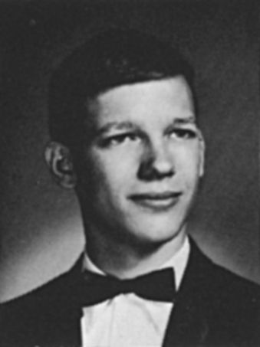
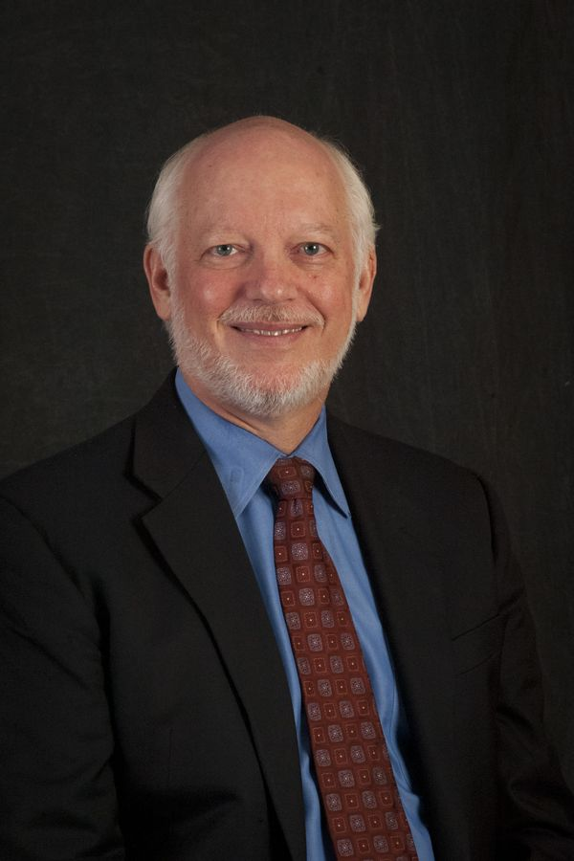
Randy Pherson
Randolph Howard Pherson, 74, passed away on January 11, 2024 at his home in Great Falls, Virginia, after a courageous battle with VEXAS, a rare inflammatory syndrome identified in 2020. Randy was the co-founder of Pherson Associates, which he started with his wife, Katherine Hibbs Pherson, to develop and share best practices in analytic thinking based on what they had learned and practiced during their careers at the Central Intelligence Agency (CIA).
Randy was best known in the international intelligence community for his thought leadership and development of Structured Analytic Techniques (SATs), a term coined by his wife to describe a set of qualitative methods to help analysts mitigate bias while framing complex issues and diagnosing possible outcomes. He was the author of 13 books on analytic thinking and presentation and sought multiple ways to share his insights through classes, presentations, and dozens of articles, particularly enjoying teaching and mentoring students across the globe.
Applying analytic thinking to his own medical issues, Randy used SATs to enable a last-minute cardiac procedure that saved his life in 2014 and chronicled the story in How to Get the Right Diagnosis: 16 Tips for Navigating the Medical System. Despite this success, he soon began experiencing a confusing array of symptoms that would not be diagnosed as VEXAS until 8 years later.
Randy Pherson was born on March 4, 1949, in Washington, DC to John R. Pherson and Annabel S. Pherson. He received an A.B. from Dartmouth College and an M.A. in International Relations from Yale University. A recipient of the Intelligence Community's Distinguished Intelligence Medal and CIA's Distinguished Career Intelligence Medal, he was serving as the National Intelligence Officer (NIO) for Latin America when he took early retirement in 2000. He guided development of Pherson Associates' government work as President from 2003-2021 and served as CEO of Globalytica, a subsidiary of Pherson specializing in classes and publications for international and private industry clients.
He is survived by his wife of 50 years, Katherine Hibbs Pherson; son Richard; daughter Amanda (Michael Pedersen); dear friend Dr. Janet Baker; and many loving family members, those he mentored and with whom he collaborated, and his fellow runners in the Great Falls Hash House Harriers. A celebration of Randy's life will be held on February 2, 2024, at 1 p.m. at Meadowlark Botanical Gardens' Atrium in Vienna, Virginia. At the time of his death, he was working with his closest medical advisers to establish a non-profit to support and educate medical providers, patients, and the public about VEXAS and other rare autoinflammatory diseases.
Remembrances

Robert Schnabel-
Edie and I met Randy and Kathy Pherson at the 25th reunion, I don't think I'd known Randy while at Dartmouth. We've stayed in touch ever since, now sadly only with Kathy. We bonded over similar age children, and the fact that both of ours and one of the Pherson's two is adopted from Korea. Randy was a wonderful person who had an extremely impressive and influential career, and always had interesting perspectives. We miss him!
Robert Lafsky-
Just an acquaintance at school, became a CIA analyst. Late in life he developed multiple medical problems that he analyzed the hell out of. Turned out he had a rare somatic X chromosome aberration called VEXAS that caused his immune system to go haywire, one that had only been discovered a couple of years before. Discussed it at length with him at concluding dinner last reunion; I actually snuck a look at the New England Journal on my phone to confirm the publication, one where doubtlessly I had skimmed the abstract and skipped to the next irrelevant thing. He wrote a book about it and there's a piece on him in the Washington Post if you want to look it up: https://www.washingtonpost.com/dc-md-va/2024/02/03/cia-analyst-rare-disease-vexas/?itid=sr_0_17bf03a5-bedc-43f0-98df-811e7e08541a. I get more from reunions meeting the people I really didn't know back when.
David Aylward-
Randy and I were in Foley House together. He was a brilliant hardcharging guy. Although we both worked in Washington for decades, we had no contact until the worst of the Covid pandemic. It was too cold to eat on the restaurant’s porch as we had planned, so we took what we considered to be a major risk and ate inside. Our shared love of government helped the friendship blossom; it was terminated too soon by his illness. In the remarkable way that he undertook addressing the complexities of the intelligence world, he figured out the strange disease killing him. I have this great sense of loss: a friendship that was building and then cut off.
Sam Cuddeback-
Although I did not know Randy during our time on campus, I had the good fortune of working with him to create an engaging panel for our “Virtual 50th reunion. During our planning phone calls and zoom meetings, Randy shared his professional pathway through his years with the CIA into creating his own consulting company with his wife. He wrote and lectured prolifically; he had an expansive client base. He shared with me his medical issues and why he’d written his book about those related challenges and the systems that perpetuated them. I always looked forward to speaking with him, appreciating his intelligence and geo-political interests. I remain genuinely grateful that he was of “the stuff our (our) institution”. I send condolences to his wife and family.

Willard Riley
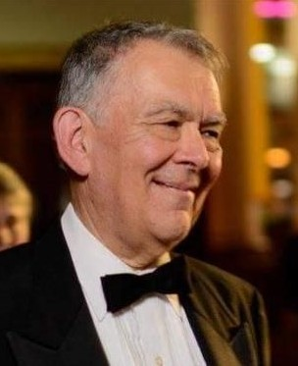
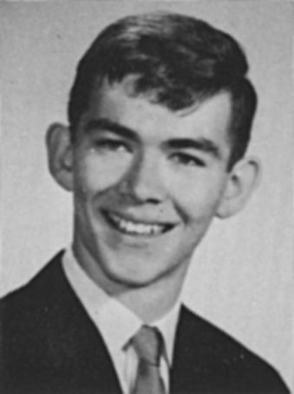
Born in 1949 in Sidney, New York, to Elsie Ruland and Ralph Riley, Bill spent his formative years in Littleton, New Hampshire, followed by academic studies at Dartmouth College.
Bill’s passion for music was ignited at a young age, particularly through his involvement in the school band and training in piano. At Dartmouth, he was introduced to the organ repertoire, kindling his interest in that instrument. His love of music and sense of adventure led him, along with his first wife Donna, to France and Germany, where he studied organ building for three years. After a brief return to the US, he and his young family moved to Montreal in 1979, where he initially worked as an organ builder, and continued tuning and repairing organs and playing in a variety of churches over the years.
In Quebec, Bill’s dynamic musical life revolved primarily around discovering and mastering various brass instruments, and being involved in as many musical endeavors as possible. He took every opportunity to make music with small groups, trios, marching bands and orchestras. He also partnered with friends to compose and produce original works.
Bill’s greatest pleasure was teaching and encouraging other musicians, and for that he was respected and loved up to and beyond his untimely death.
He left us on April 10, 2021, when his heart failed him. He is survived by his son Patrick, daughter Rose, wife Toni, stepsons Phillip and Patrick, and sisters Mary and Carol, as well as many nieces, nephews and grandchildren.
We will miss his quiet chuckles, his silly puns, and his passionate curiosity.

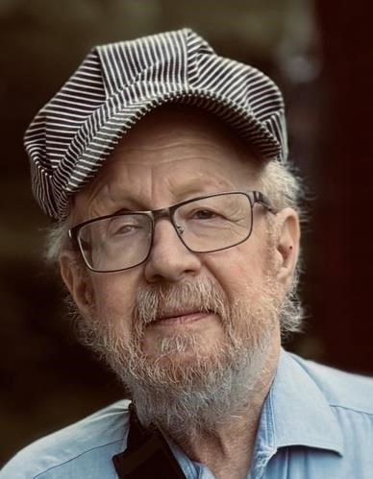
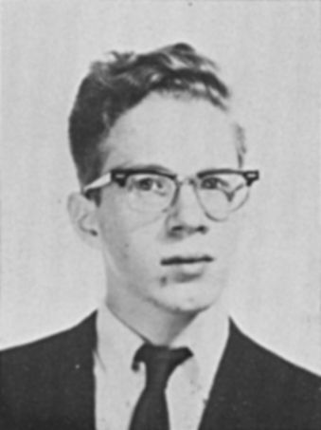
Peter Roitman
Peter Roitman, an accomplished scientist, beloved husband and brother, and longtime resident of Gaithersburg, MD, died October 2, 2025, following a courageous battle with cancer of the throat. He was 76.
Peter was the first child of Harold and Elisabeth Roitman and the eldest of five siblings. As a child growing up in Belmont, Massachusetts, he enjoyed reading science fiction and conducting experiments with his home chemistry set. He spent his summers with his family on Stinson Lake in Rumney, New Hampshire. After graduating from Belmont High School, Peter completed his undergraduate and master's degrees at Dartmouth College. He obtained his doctorate in engineering from Princeton University in 1977.
That same year, he joined the National Bureau of Standards (now the National Institute of Standards and Technology.) In his own way, Peter was a patriot, feeling an obligation to use his intellect to serve his country. He worked his entire career at NIST, publishing numerous papers and conducting research on topics including radiation effects on microchips, silicon materials and processing, SOI technology, and electron microscopy.
In 1992, he and his coauthors received the 1992 NSREC Outstanding Conference Paper Award at the IEEE Nuclear and Space Radiation Effects Conference.
He met his beloved wife, Doris Poulin Roitman, on a ski trip to the Alps and married her in 1986. As a couple, they enjoyed skiing, traveling, and gourmet cooking. He had a wide-ranging curiosity and was an avid reader of American and European histories.
Peter adapted and endured through many health challenges, including kidney failure, and received a donated kidney in 2018. After losing his eyesight in 2022, he learned to use various computer-assisted technologies to stay engaged and continue his lifelong learning and literary appreciation.
He is survived by his wife, Doris, as well as his sister Judy from Oak Ridge, TN, his brother Michael from Boston, MA, sister Jennie from Oakland, CA, and several nieces and nephews.
____________________________________________________________________________
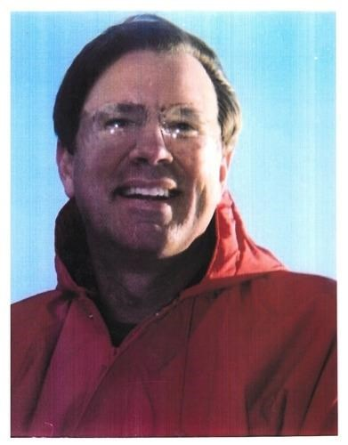
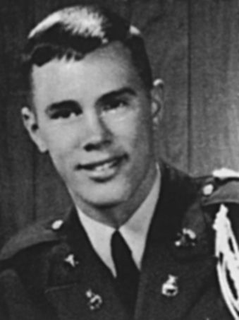
Howard Smith
Dr. Vance Howard Smith, age 75, passed away on Saturday, May 4, 2024. He was born in Lexington, Kentucky on March 24, 1949, to Howard & Penny (Price) Smith and served his country in the US Air Force from June 1975 through October 1983. He married the former Deborah Paris on June 6, 1986. Dr. Smith had been a Vascular Surgeon for his entire career until retiring in 2015.
Vance had a wide array of interests and participated in many events in his earlier years. One of them was being an Eagle Scout. Vance attended military school in New Mexico, graduated with distinction at Dartmouth College, then went on to receive his doctorate degree from the University of New Mexico School of Medicine. In his adult years, he found many passions including traveling, electronics, sailing, hunting, and vehicles, especially Land Rovers and British cars.
SURVIVORS
Deborah Smith, wife, of Muskegon; children Jocelyn Smith (Peter Greydanus) of Richmond, Virginia, Ryan (Katrina) Smith of Hanover Park, Illinois and Christopher Garrison of Muskegon, Michigan; brothers Anthony Smith, Craig Smith, and sister Kimberly Williams; grandchildren, Mira, Eda, Ronin, and Dresden.
Preceding him in death are his parents Howard and Penny (Price) Smith.

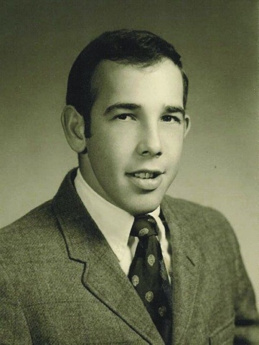
Bruce Tepper
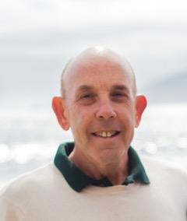
Robert Bruce Tepper—beloved husband, father, brother, uncle, mentor and friend—died at home in Los Angeles from cancer on September 17, 2024 after what he called a “charmed life.” Born in New Jersey in 1949, Bruce made his way from Washington D.C. to Nashville to New Hampshire as part of the last all-male class (1971) at Dartmouth College. There he studied history, learned to ski, built lifelong friendships, and met his wife of 53 years, Belinda Wilkins. In 1978, after Bruce earned his Juris Doctorate and Master’s (Urban Affairs) degrees, he and Belinda moved from St. Louis to Los Angeles. In his adopted hometown Bruce built a professional reputation as a fierce litigator, specializing in land use and water rights appeals (including many published decisions) first at Kane, Ballmer, & Berkman and then in his solo practice, which he launched in 2002. In addition to his advocacy, Bruce was known as a valued mentor training many junior attorneys with his exacting standards. Even as a sole practitioner, Bruce prioritized partnering without outside firms in order to continue this important work. Bruce was also widely known for his legal writing; his publications were regularly cited by numerous Courts of Appeal as well as the California Supreme Court. True to his profession, Bruce delighted in tenacious advocacy and lively debate in- and outside the courtroom, often incorporating his characteristically dry (and sometimes biting) humor. He brought this spirit into his role as an intensely involved parent to son Jacob Tepper and daughter Laura Kate Tepper. He was a grill-master and sports fan (Dodger Blue). And, less well known, he was also an appreciator of beauty ranging from his preferred soundtrack of classical music (as curated by KUSC) to the natural splendor of California’s Central Coast (where he and Belinda designed and built a home) to displaying fresh cut flowers preferably from local farmers’ markets. He is survived by Belinda; Jacob and his wife Danielle Tepper; Laura Kate and her husband Josh Bukstein; four grandsons—Grant Tepper, Cole Tepper, Theodore Bukstein, and Jonah Bruce Bukstein; his three sisters—Peggy Hittner, Wendy Tepper and Trisha Wisse; and his mother, Elaine Tepper. “The hill winds know his name.”

Remembrances
Dave Paradise-
True to form, Bruce made a valiant effort to beat this thing, which was diagnosed in the early part of the year. Because of his immuno-compromised status, chemo and surgery were not possible so he started an experimental immunotherapy for which he was uniquely qualified. My wife and I visited Bruce and Belinda in LA in May, and he looked pretty good and hopes were high for success. He made the old Dartmouth try, but eventually he had to accept that it was not working and was causing a lot of pain. Around about July he and Belinda opted with grace to accept the inevitable and alleviate the pain. Bruce was still going pretty strong through most of the summer, talking to friends and family frequently. I stopped by in late August and had a good conversation over old times, and his daughter Laura was also down from San Francisco. In early September they went to hospice care, and his sisters and other family began coming in. Bruce passed peacefully the night of September 17. Bruce was a true gentleman of the old school, and he brought a unique perspective to everything and everyone he touched. Dartmouth will miss him.
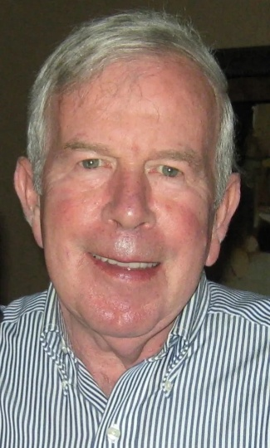
Scott Wiley
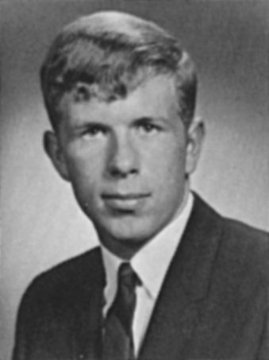
Scott Taylor Wiley, of Brunswick, passed away on August 1, 2025 from cancer at the age of 75 years old.
Scott grew up in Oradell, NJ. In high school, he was a talented soccer and tennis player, captaining both teams, and he loved working on cars. When Scott was only 15 years old, he achieved the rank of Eagle Scout. He spent considerable time in his teen and college years at Long Beach Island on the Jersey shore, working as a short-order breakfast cook and ice cream truck operator, and using much of his free time to surf.
He graduated with a degree in economics with honors from Dartmouth College and earned his MBA in finance from the University of Chicago. He began his business career with J.P. Morgan & Co. as an oil analyst in the Trust and Investment division. He became a vice president at J.P. Morgan & Co. and helped to form the company’s first proprietary energy fund to make direct investments in the oil and gas industry. In 1981, Scott formed his own energy investment banking firm, named Copeland, Wickersham, Wiley, and Company. Over the years, the firm grew to about 30 employees with various offices in London, New York, Houston, and Hong Kong. The client base was primarily large banks, institutional investors or energy companies. During his professional career, he was a member of the Finance Analysts Federation, New York Society Security Analyst, and ultimately the president of the National Association Petroleum Investment Analysts in the early 1980’s. In 1989, Scott created his own firm, Wiley Capital Inc., to raise private equity for small energy companies. Scott was dedicated to his career and made many sacrifices for his family in service of his career. His career took him all over the world with large spans in Texas, France, and Australia.
In 1972, Scott married his high school sweetheart, Joy McArthur, who grew up two blocks away in Oradell, NJ. While Scott and Joy had known each other since elementary school, the sparks of their relationship began in a high school chemistry lab. They were married for 53 years, and had two children, Peter and Glen. While in New Jersey, he served on the local Boy Scouts of America Council and the Dartmouth Club of Northern New Jersey. Also, he was known for his love for tennis, his meat carving skills, and his meticulous landscaping of his home’s property. In late 2009, Scott and Joy made a major life transition when they left their life-long residency in New Jersey to move to Brunswick, Maine to be close to their son, Peter, and their grandchildren.
In his 60s, Scott fulfilled a big item on his bucket list with the purchase of his first Corvette. Scott and Joy were active members in the Vettes of Coastal Maine, a social club for Corvette owners. Scott loved driving his Corvette, eating a lobster roll, and monitoring his financial investments. He was always proud of his children and grandchildren, and especially enjoyed watching his grandchildren play soccer or perform on stage.
Around 1920, Scott’s grandfather from Evanston, Ill. purchased a second home in New York’s Finger Lakes region in a now charming one-traffic light hamlet of the town of Jerusalem called Branchport. He absolutely loved to spend summers at the Branchport home, tinkering in the yard, chatting with neighbors, or sitting out on the back porch, looking out at Keuka Lake. With no television or internet at the house, Scott read many fiction books there about spies, crime, and mysteries, including many novels by Harlan Coben and Vince Flynn.
Scott is survived by his wife, Joy, of Brunswick; his sons, Peter of Brunswick and Glen of Miami, Fla.; as well as grandchildren, Simone, Ian, and Naomi; his sister, Sindy McCrystle, and brother-in-law, Tom, of Charlotte, NC; niece, Meagan (McCrystle) Soffera, and nephew, Kevin McCrystle, and their families.

Dick Wooster
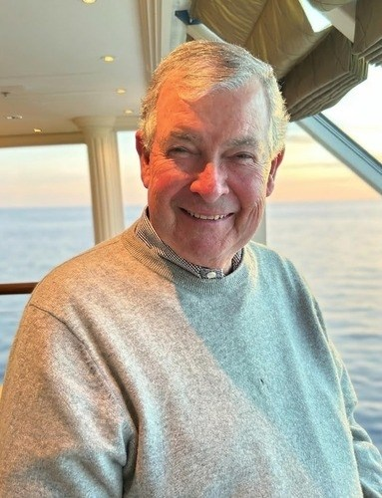
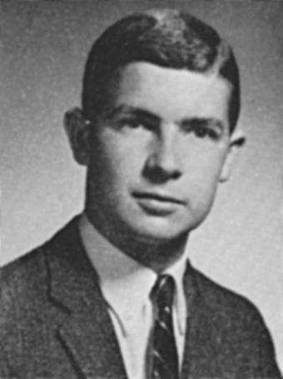
Richard Willet Wooster, a veteran finance executive, hedge fund founder, and devoted family man, passed away on February 28, while on safari. He was 77.
Born on January 12, 1949, in Glen Ridge, New Jersey, Richard was the son of John T. and Mary S. Wooster.
A proud member of the Dartmouth College Class of 1971, Richard was a brother of Bones Gate and a lifelong Dartmouth football enthusiast - a passion he also shared with the NE Patriots. He later earned an MBA from Stanford University and began his career at Morgan Stanley. He eventually served as SVP at Oppenheimer & Co. and later founded the hedge fund Dune Partners.
Richard met Liz, who immediately became his "Sweetie," in 2009 and they were married in 2011. They spent 17 of the happiest years of their lives together.
Richard was a longtime member of Winged Foot Golf Club. Richard and Liz moved to Loblolly in Hobe Sound in 2014, which quickly became Richard's favorite place.
A devoted family man, Richard cherished time with his loved ones. He is survived by his wife, Liz; his stepchildren, Jonathan Hopper (Dominic), Ally Hopper (Josh), and Katey Zeig (Alex); his grandchildren, Eloise and Charles; his brother, Thomas Wooster (Sandra); his siblings-in-law, Ann Pulver (Scott), Cindy Rehm, and JD Rehm (Kathy); his nieces and nephews, Scott Wooster (Gracy), Cybill Phelan, and Timothy Wooster (Michelin); his step-nieces and nephews; and six great-nieces and great-nephews. He was preceded in death by his parents, John and Mary Wooster; and his brother, John Wooster.
Richard will be remembered for his intelligence, integrity, quiet generosity, his impish smile, and unwavering dedication. He formed lifelong bonds through Dartmouth and Bones Gate, Winged Foot, and Loblolly. His legacy lives on in the family he nurtured, the communities he strengthened, and the many lives he touched through his work, leadership, and kindness.
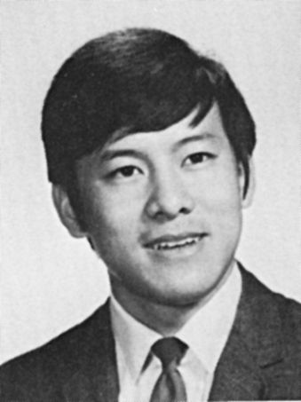
Charles Young
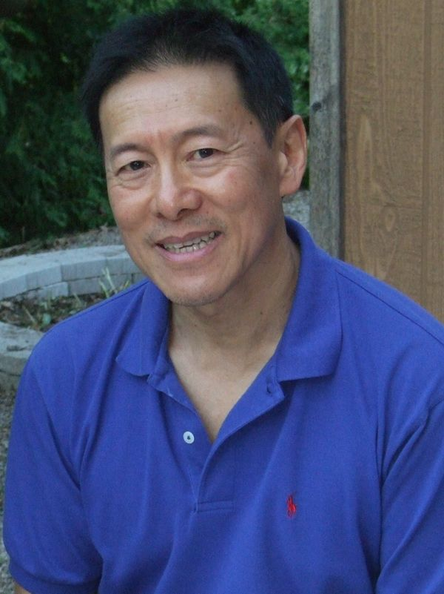
YOUNG, F CHARLES With profound sadness we announce Charles' passing on November 3, 2025, after a 17-month battle with cancer. Born in Kingston, Jamaica on May 25, 1949, Charles devoted himself to family, friends and community. He was known for his intelligence, his compassion, and his joyful presence. He was always ready to lend a hand to those in need: family, friends, colleagues, or even strangers. He is now reunited with his beloved mother, Annie; father, Kenneth; and sisters, Maria and Madge. His legacy lives on in his devoted wife of 50 years, Mavis; brothers, Frank (Mavis), Howard; and sister Gloria; sons, Ken (Qin) and Andrew; granddaughters Aubri and Erin, and all who had the privilege of knowing him.

